**22BCE0476**

**AMAN CHAUHAN**



BCSE308P - Computer Networks Lab

LAB REPORT

DA-1 CPT & BASIC NETWORKS

COMMANDS

**1. CPT**

1. Basic commands

2. P2P

3. Hub based network

4. Switch based network

5. Router based network

6. Repeater based network

7. Bridge based network

8. DNS

9. Multi server

10. DHCP

11. FTP

12. Subnetting (1 to 8)

13. VLSM Subnetting

**CPT**

**1. Basic Networking Commands**

(a) ipconfig

From the command prompt, type ipconfig to run the utility with default options. The output of the default command contains the IP address, network mask, and gateway for all physical and virtual network adapters. The ipconfig command supports several command line options.

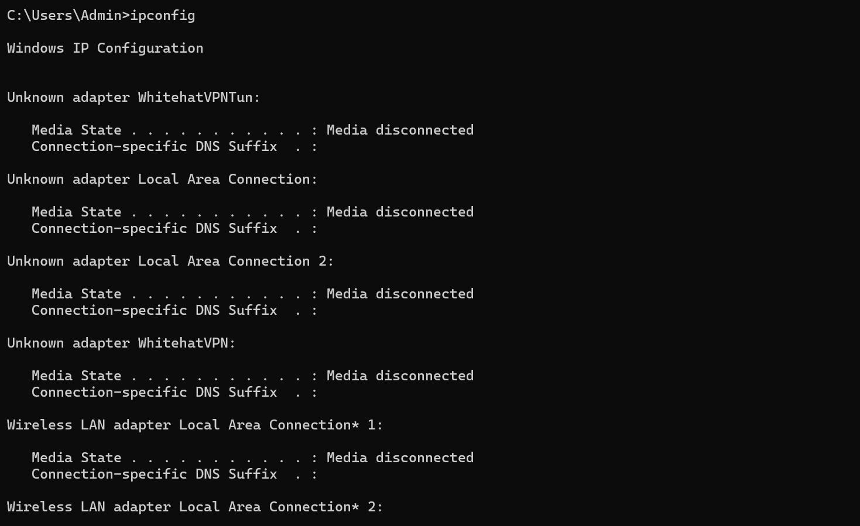

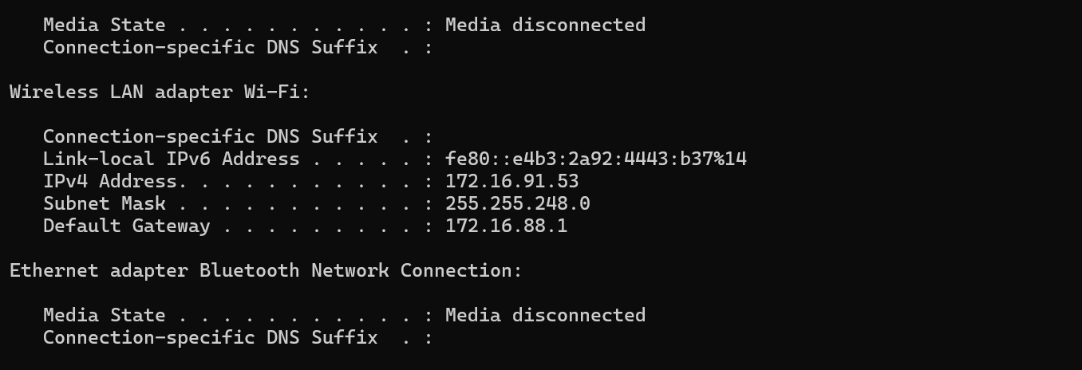

(b)ipconfig/all

This option displays the same IP addressing information for each adapter as the default option. Additionally, it displays DNS and WINS settings for each adapter as well as a whole host of additional information.

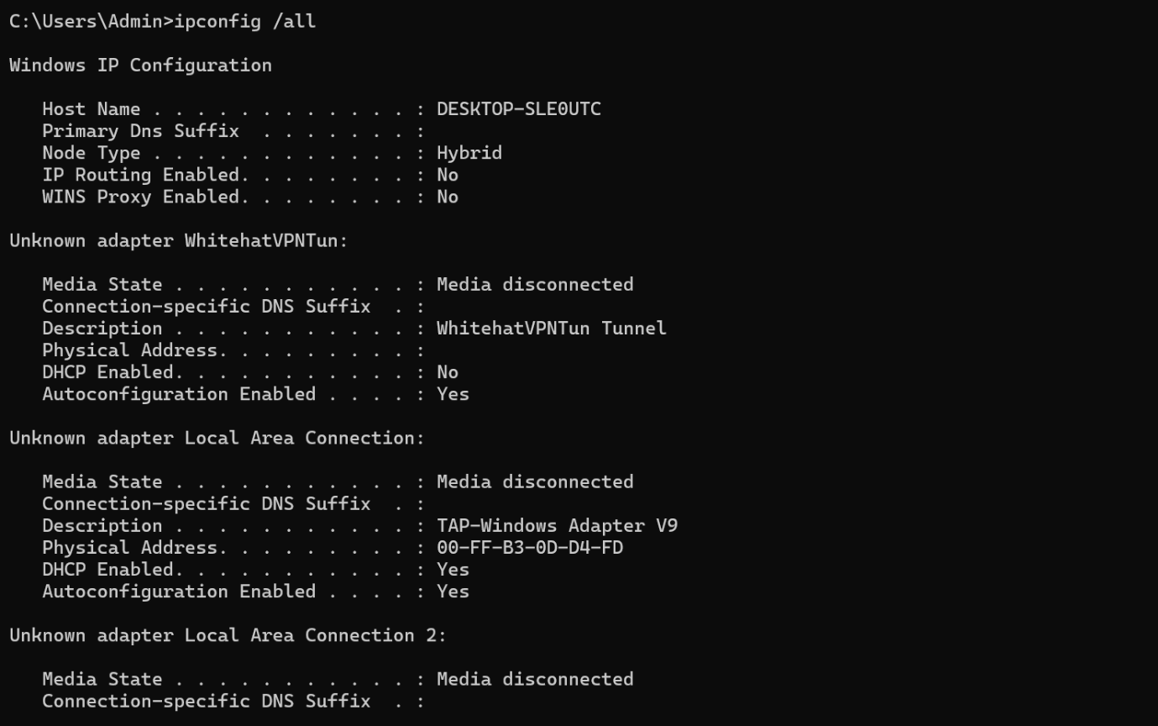

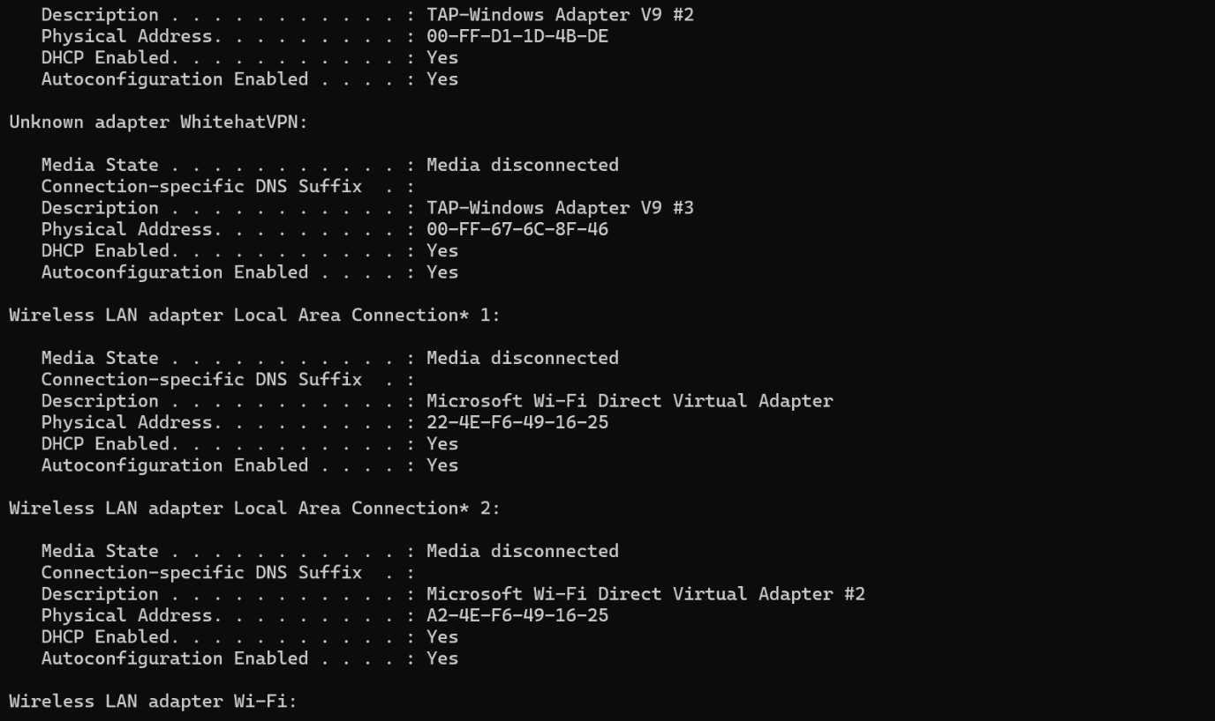

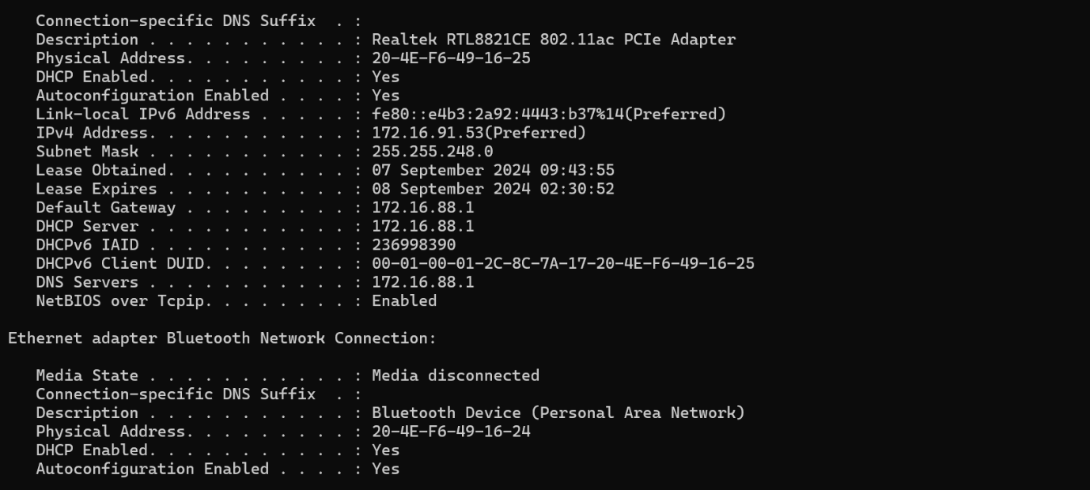

(c) NSLOOKUP

nslookup is an abbreviation of name server lookup and allows you to query your DNS service. The tool is typically used to obtain a domain name via your command line interface (CLI), receive IP address mapping details, and lookup DNS records.

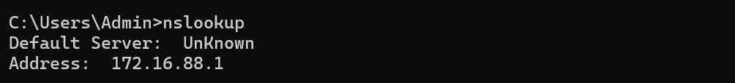

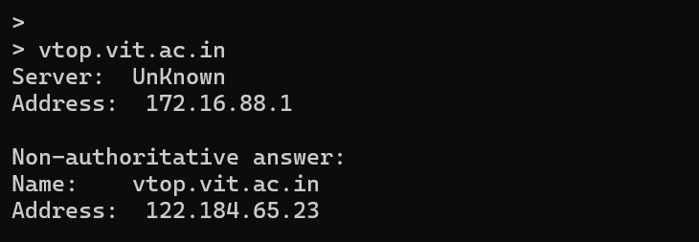

(d) PING

A ping (Packet Internet or Inter-Network Groper) is a basic Internet program that allows a user to test and verify if a particular destination IP address exists and can accept requests in computer network administration. Ping works by sending an Internet Control Message Protocol (ICMP) Echo Request to a specified interface on the network and waiting for a reply. When a ping command is issued, a ping signal is sent to a specified address. When the target host receives the echo request, it responds by sending an echo reply packet.

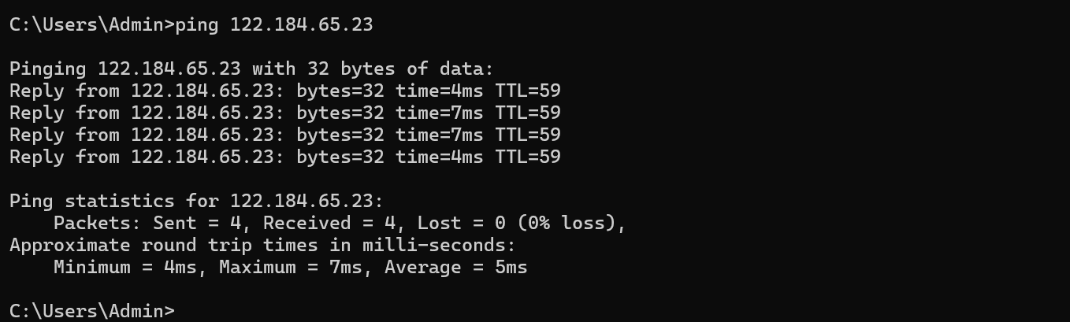

(e) TRACERT

Traceroute is a network diagnostic tool used to track in real-time the pathway taken by a packet on an IP network from source to destination, reporting the IP addresses of all the routers it pinged in between. Traceroute also records the time taken for each hop the packet makes during its route to the destination. Traceroute most commonly uses Internet Control Message Protocol (ICMP) echo packets with variable time to live (TTL) values.

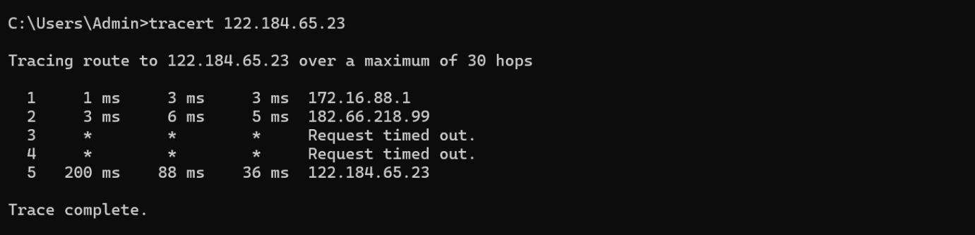

(f) NETSTAT

-S Netstat (network statistics) is a command-line network utility that displays network connections for Transmission Control Protocol (both incoming and outgoing), routing tables, and a number of network interface (network interface controller or software-defined network interface) and network protocol statistics. -S Displays statistics by protocol. By default, statistics are shown for the TCP, UDP, ICMP, and IP protocols. If the IPv6 protocol for Windows XP is installed, statistics are shown for the TCP over IPv6, UDP over IPv6, ICMPv6, and IPv6 protocols.

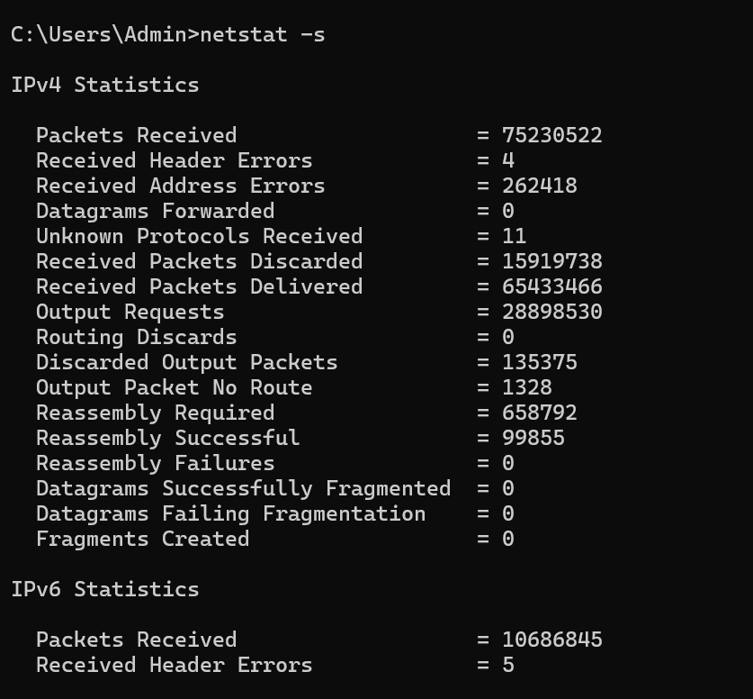

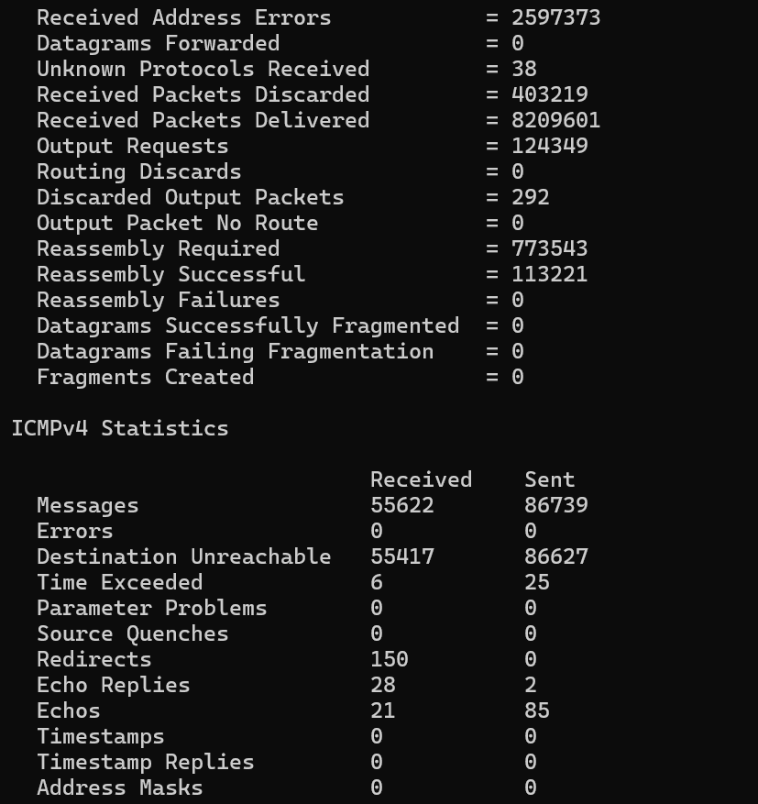 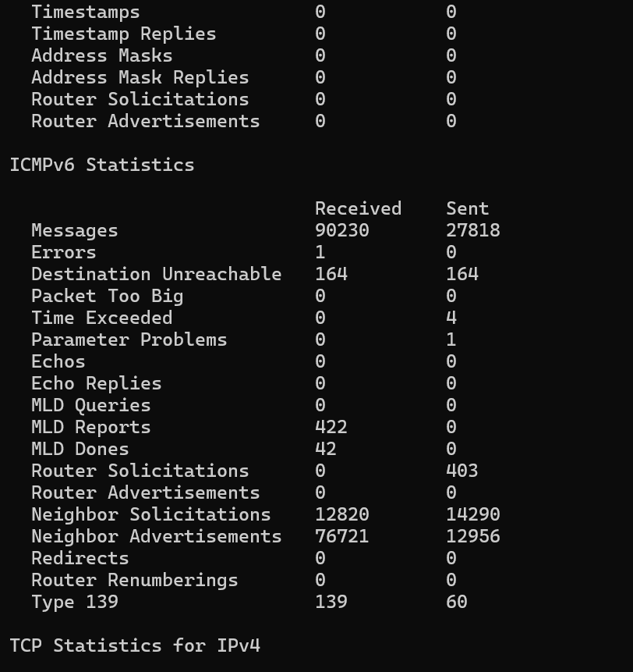 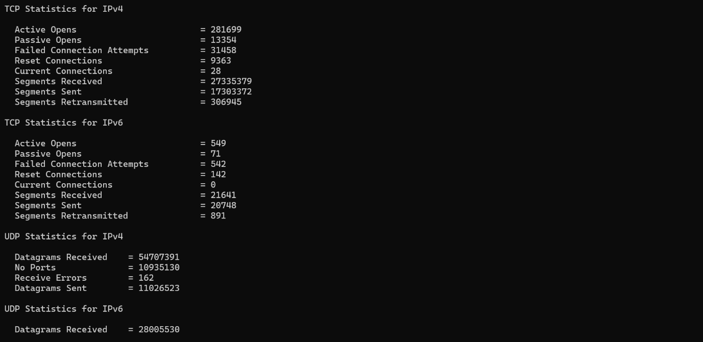 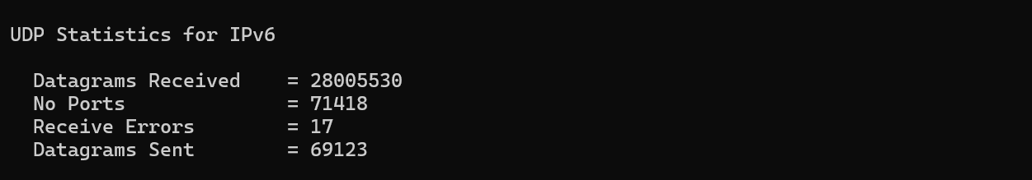

(g) ROUTE

Route command is used when you want to work with the IP/kernel routing table. It is mainly used to set up static routes to specific hosts or networks via an interface. It is used for showing or update the IP/kernel routing table.

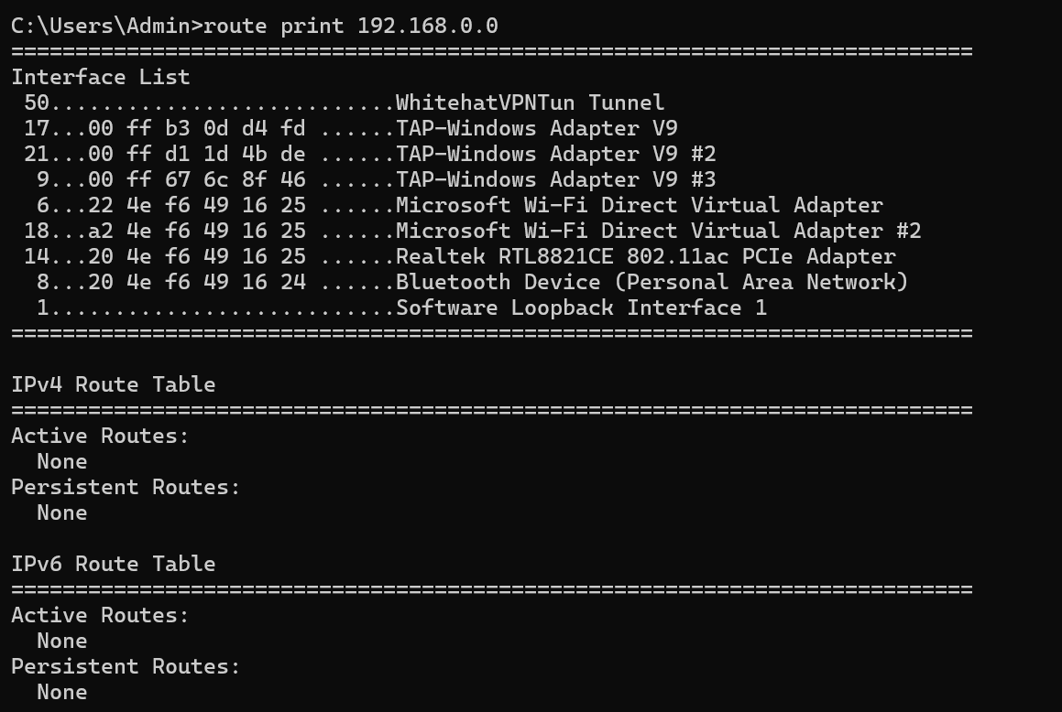

**2. Peer to Peer network**

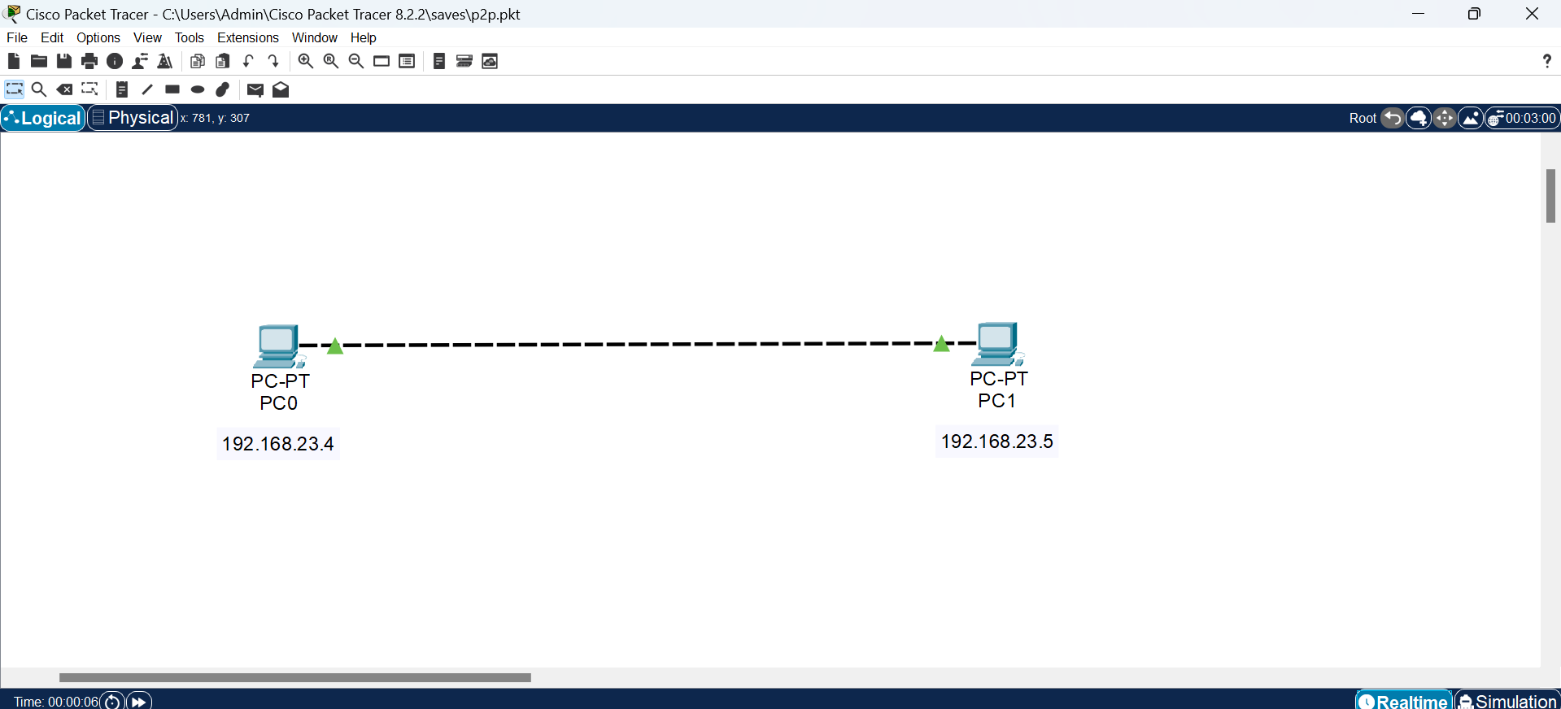

Simulation of message going from PC0 to PC1 and PC0 receiving an acknowledgement:

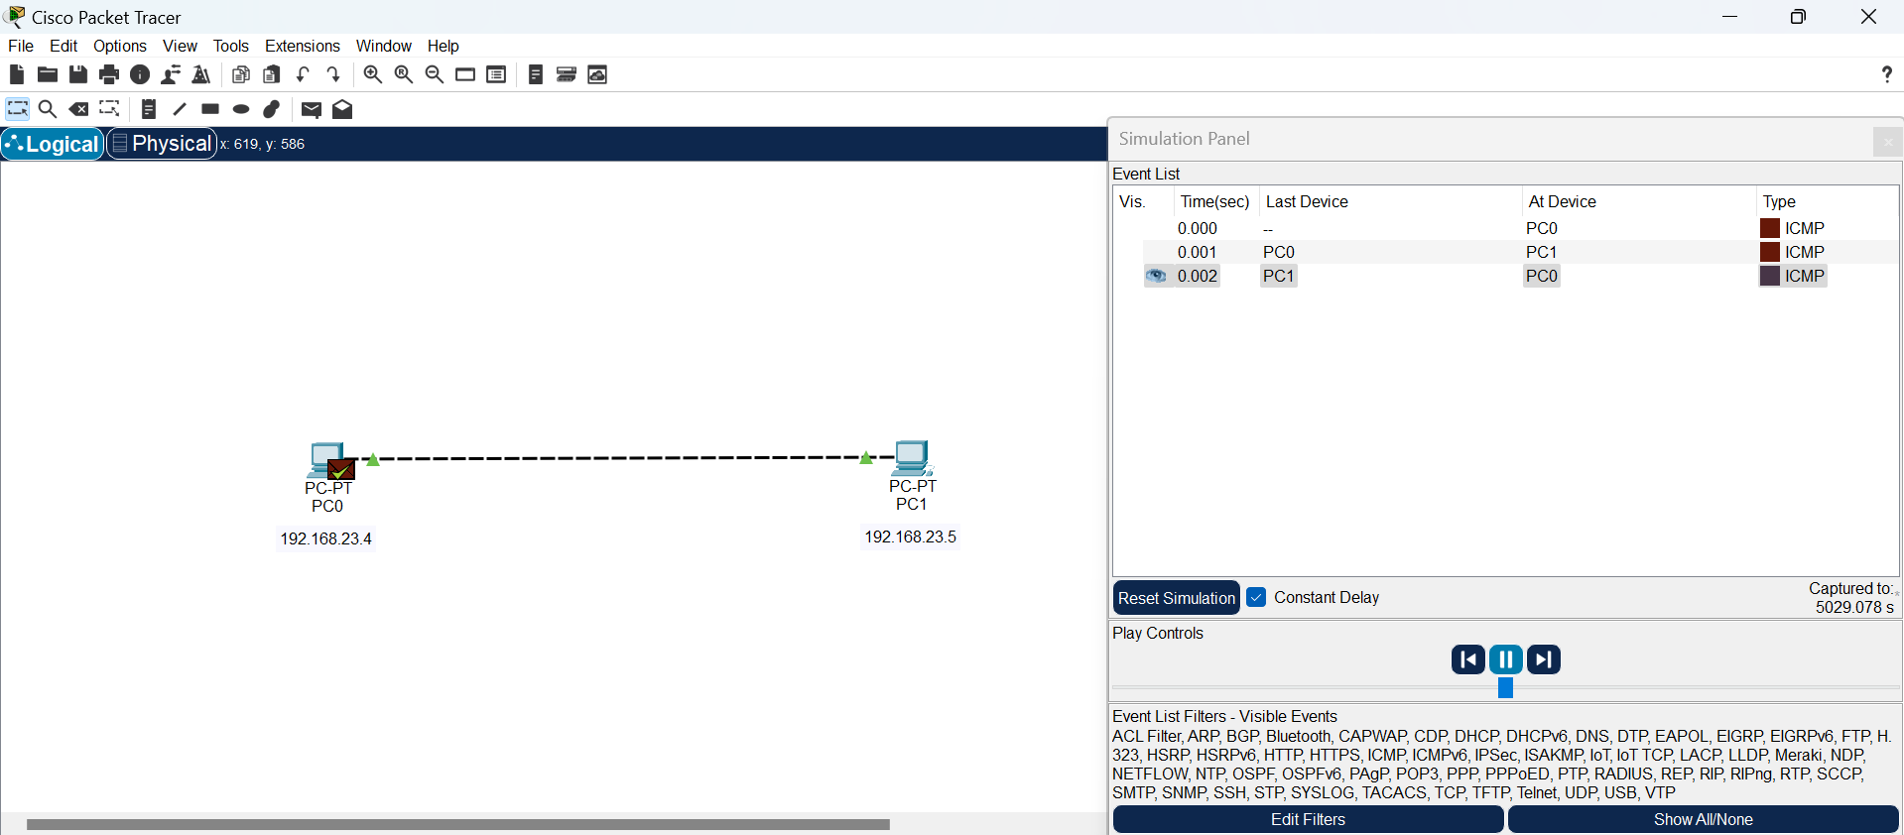

Pinging:

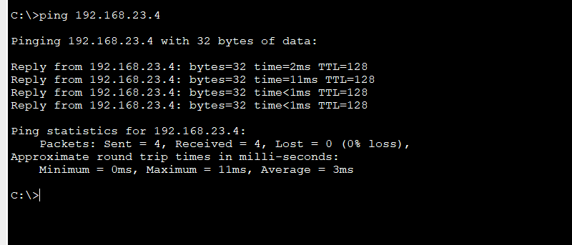

**3. CPT Hub Based Network**

Broadcasts data to all network devices.

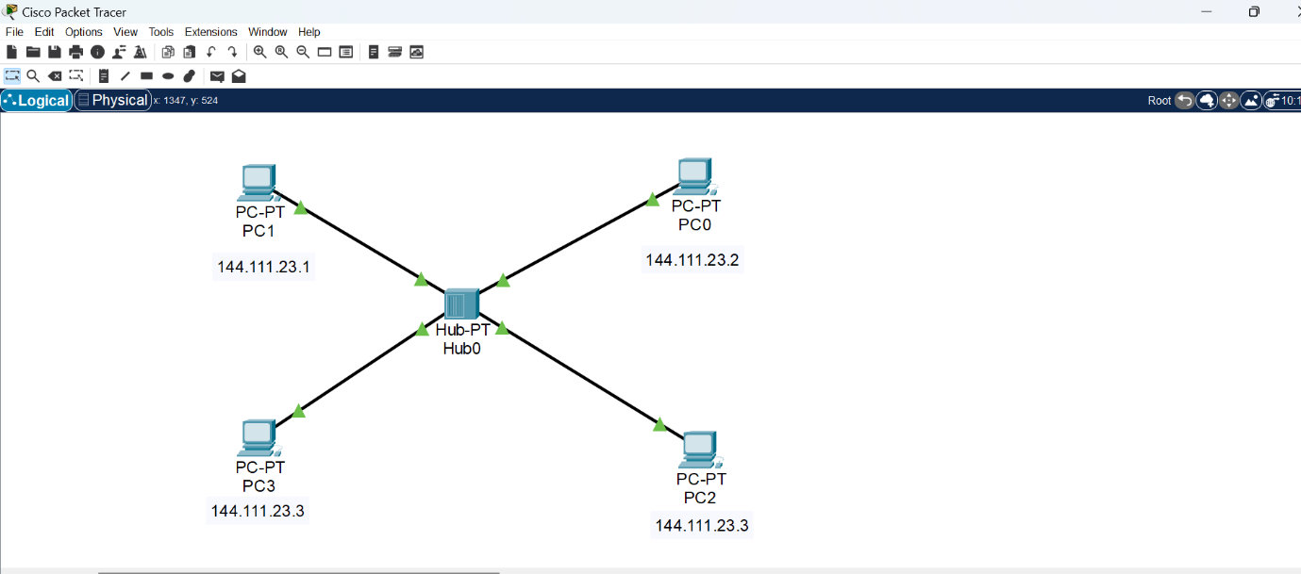

Simulation of message going from PC1 to PC3 and PC1 receiving an acknowledgement:

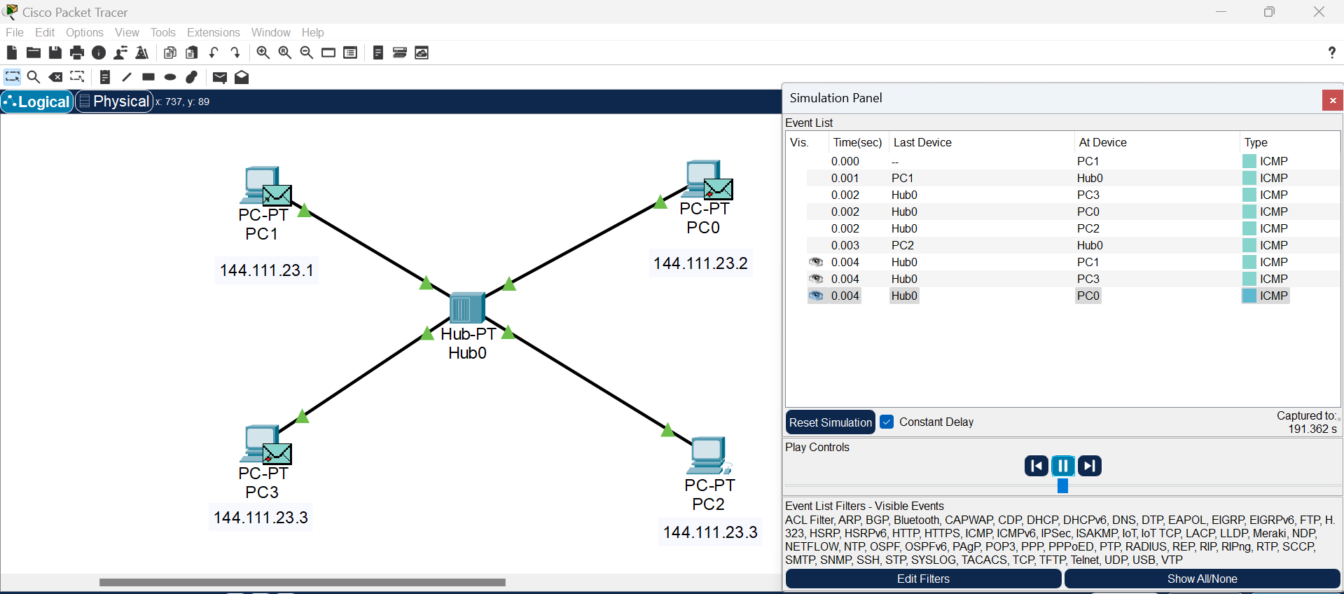

**4. Switch based network**

Different from hub in the way that it broadcasts the data to specific devices.

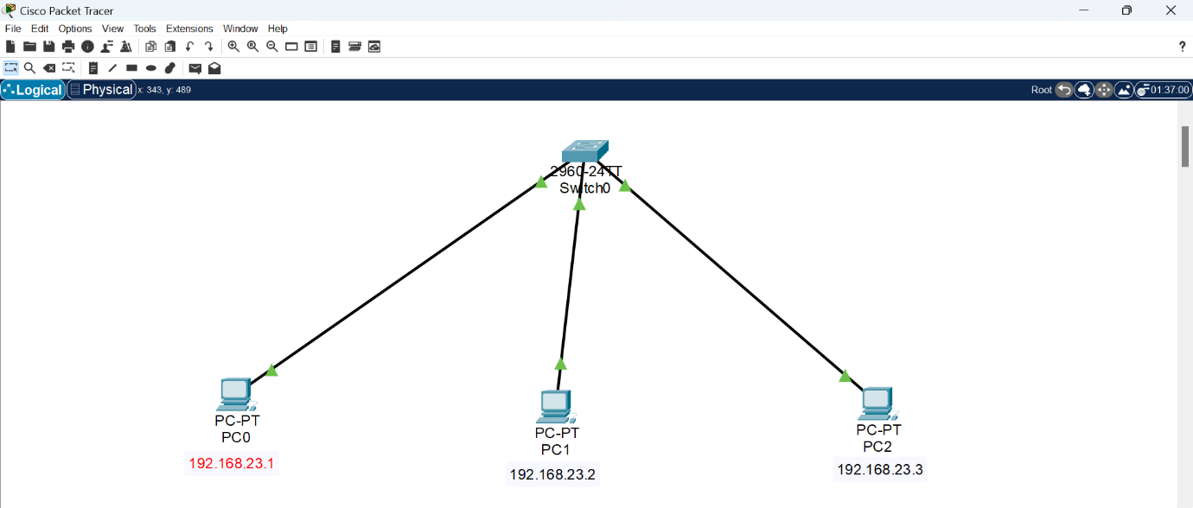

Simulation of message going from PC0 to PC2 and ACK being received by PC0:

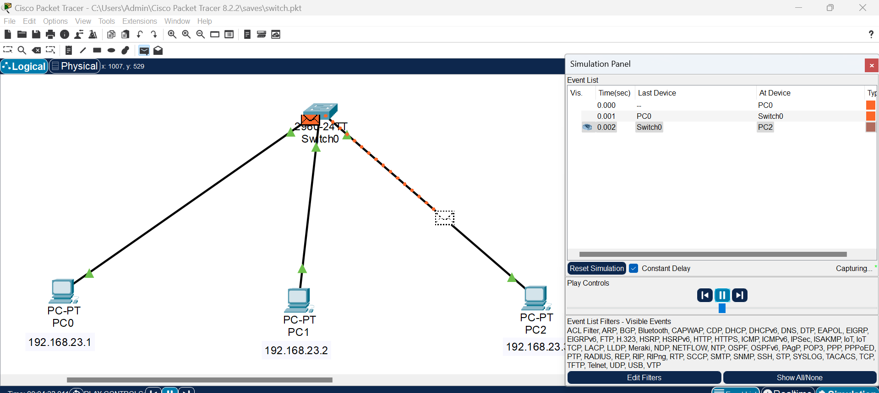

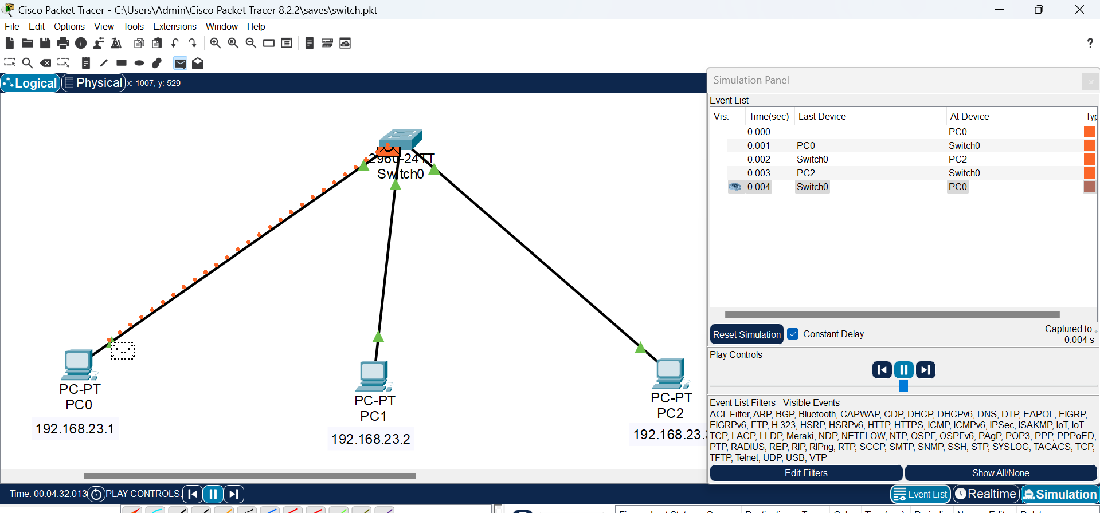

Switch table:

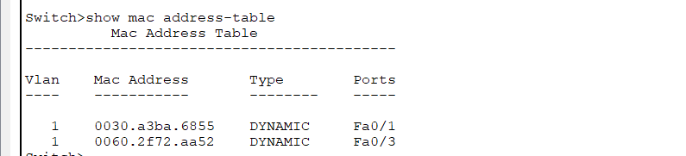

**5. Router based network**

A router connects multiple devices to the internet and manages traffic between networks.

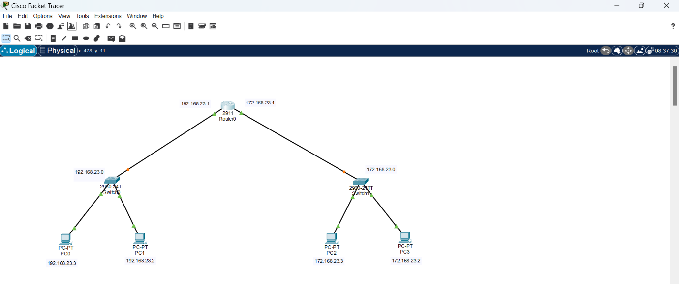

Simulation of message going from PC0 to PC2 and PC0 receiving an acknowledgement:

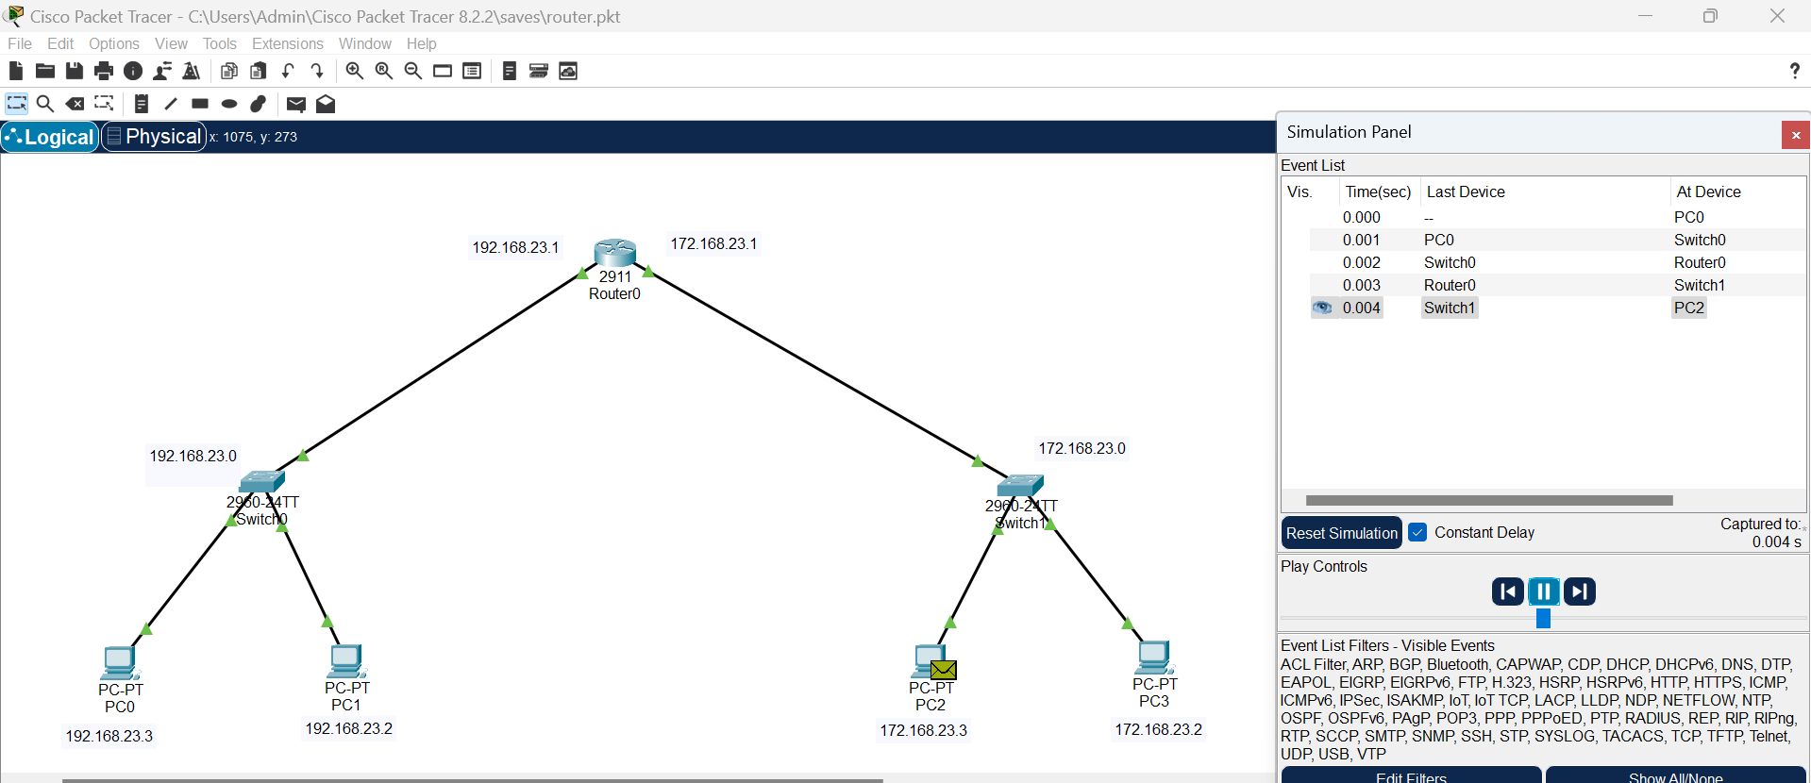

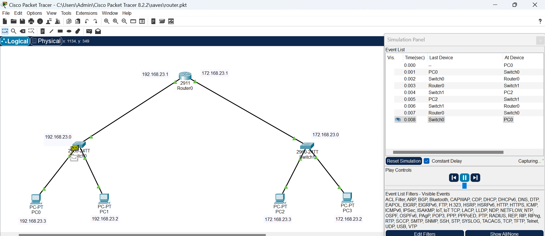

**6. Repeater based network**

A repeater extends the range of a signal so that it can reach farther or get around an obstruction.

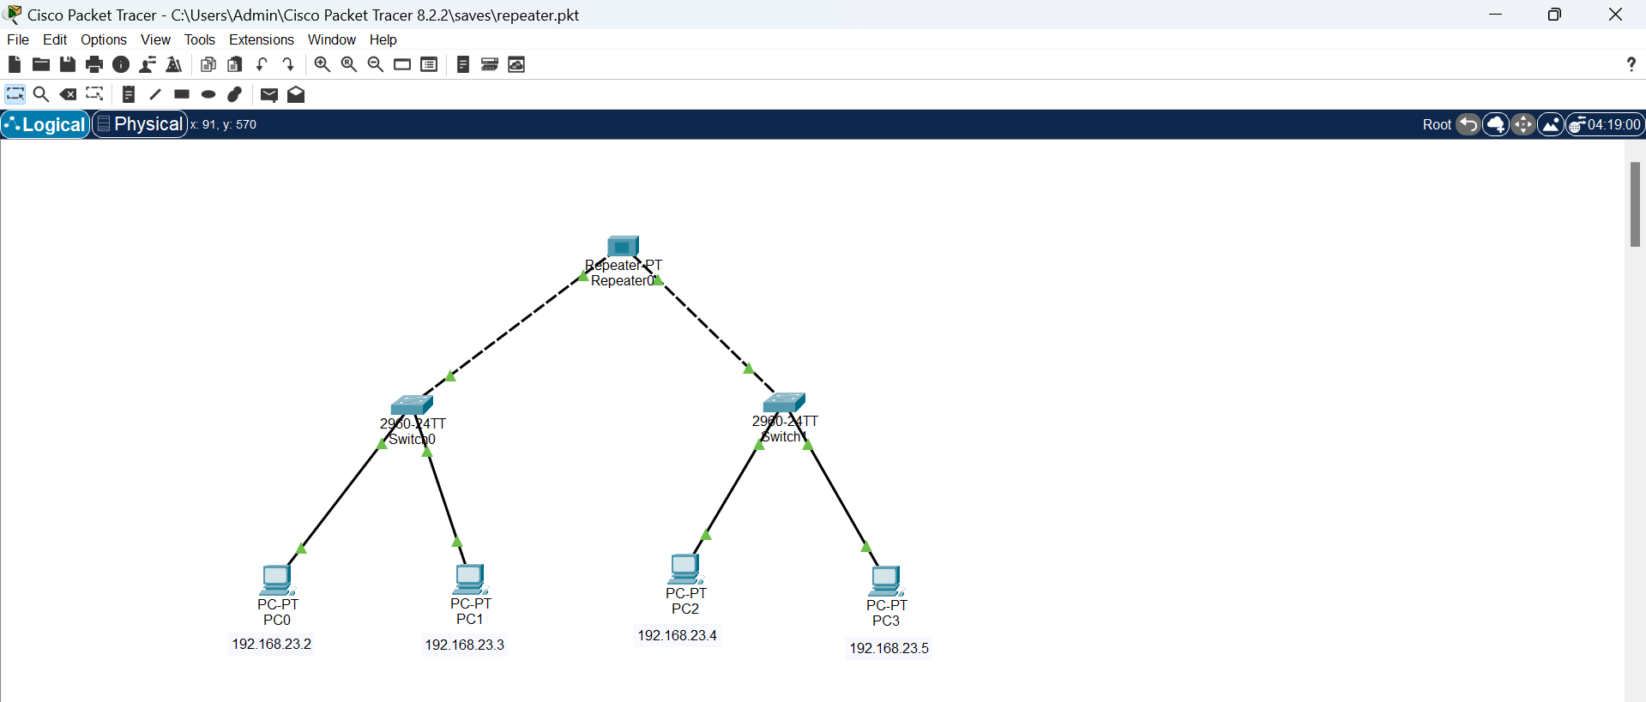

Simulation of message transfer between PC0 and PC3:

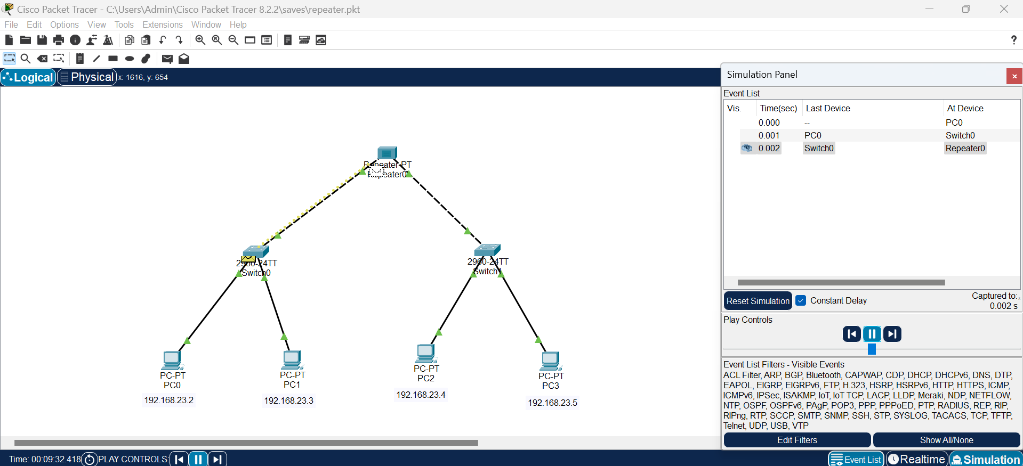

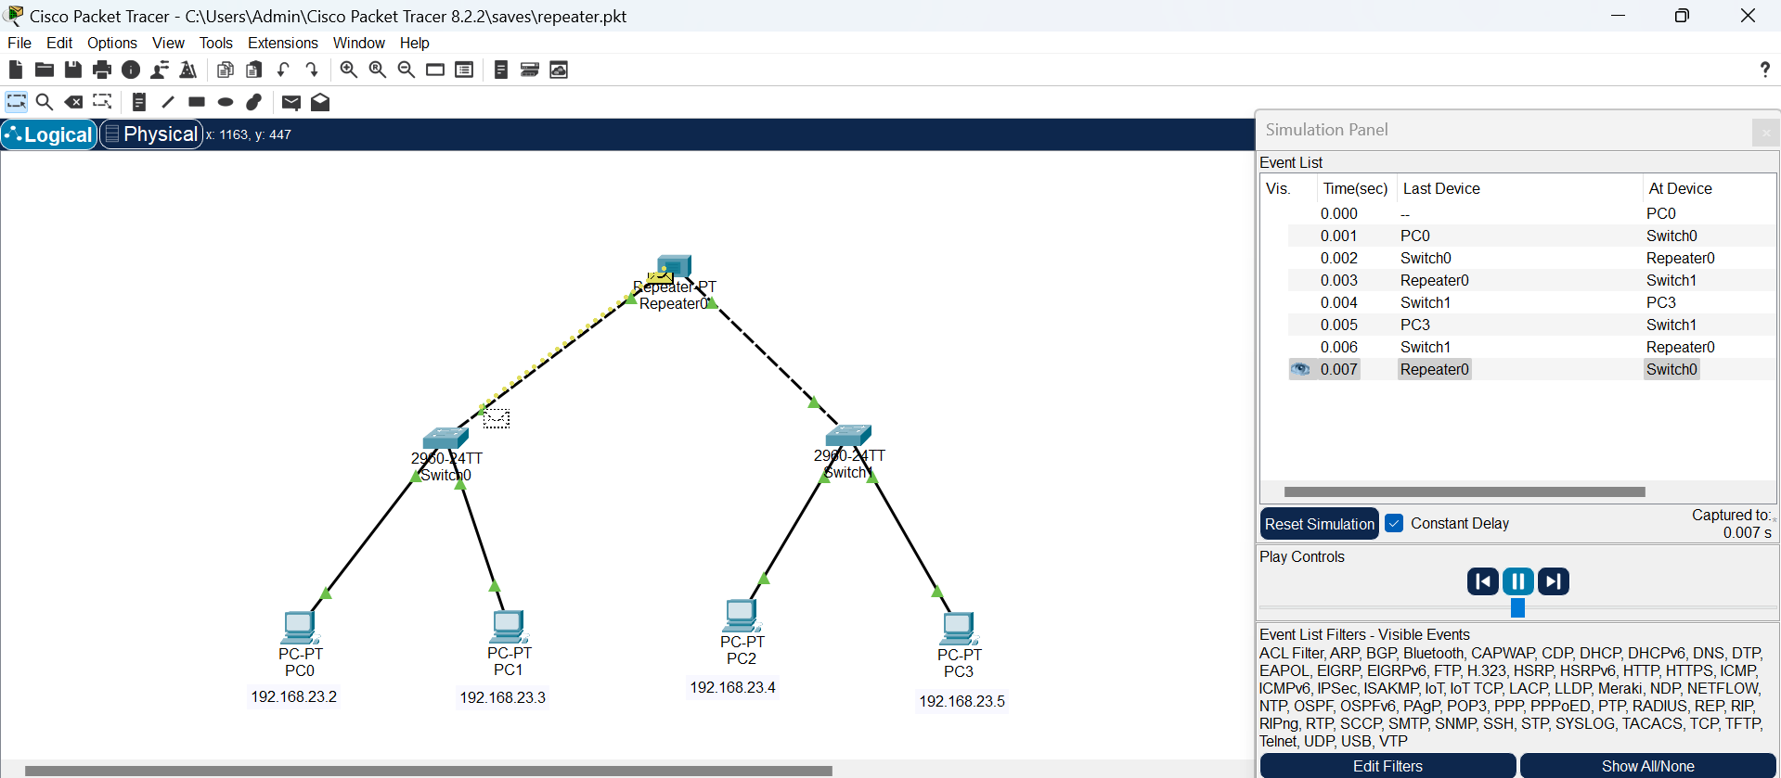

**7. Bridge Based Network**

A bridge connect similar types of networks

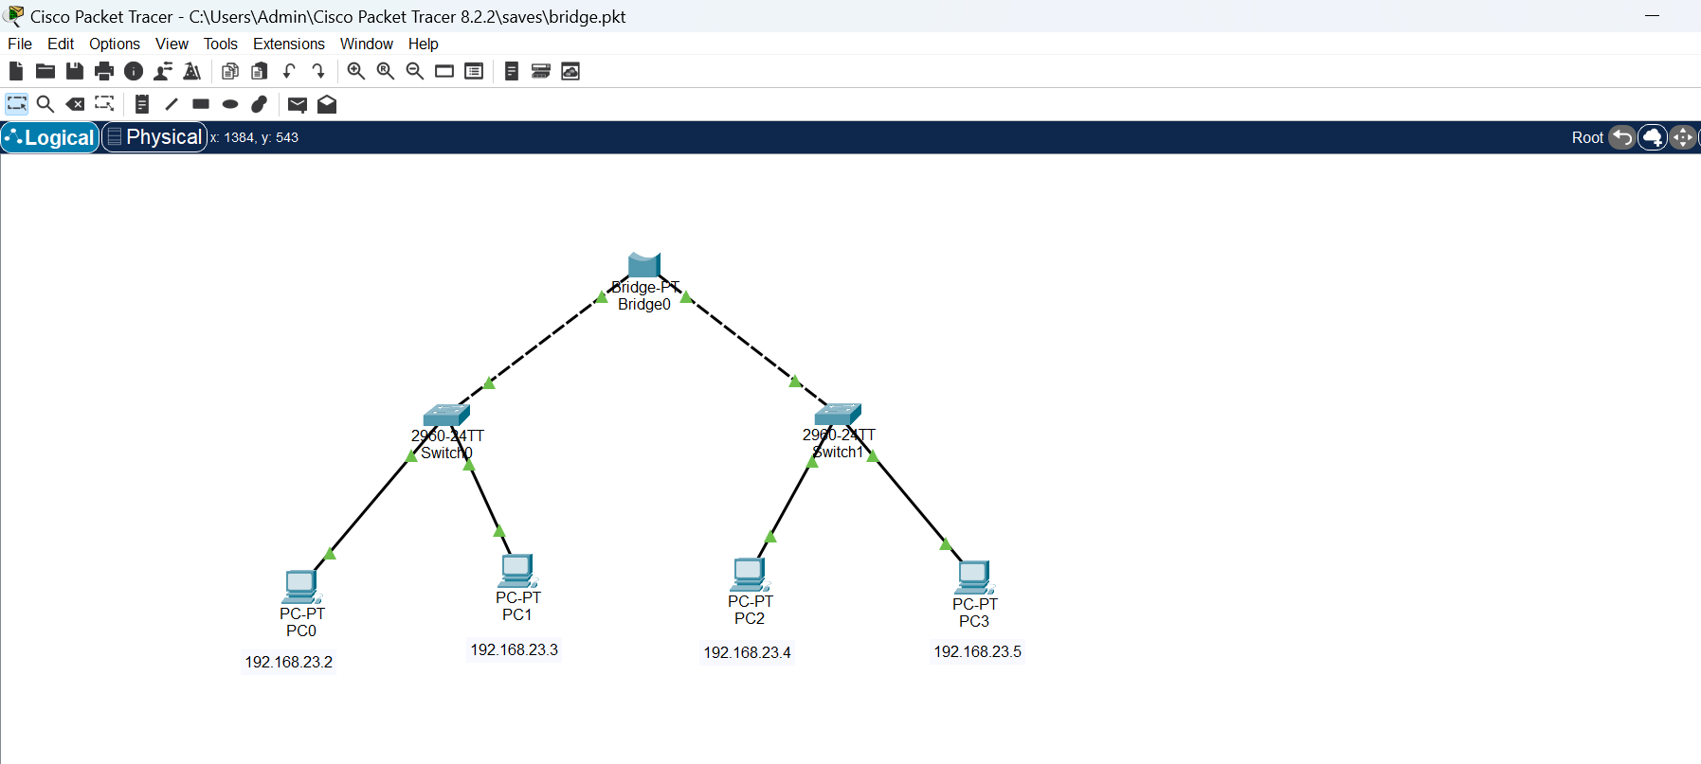

Simulation of message transfer from PC0 to PC3:

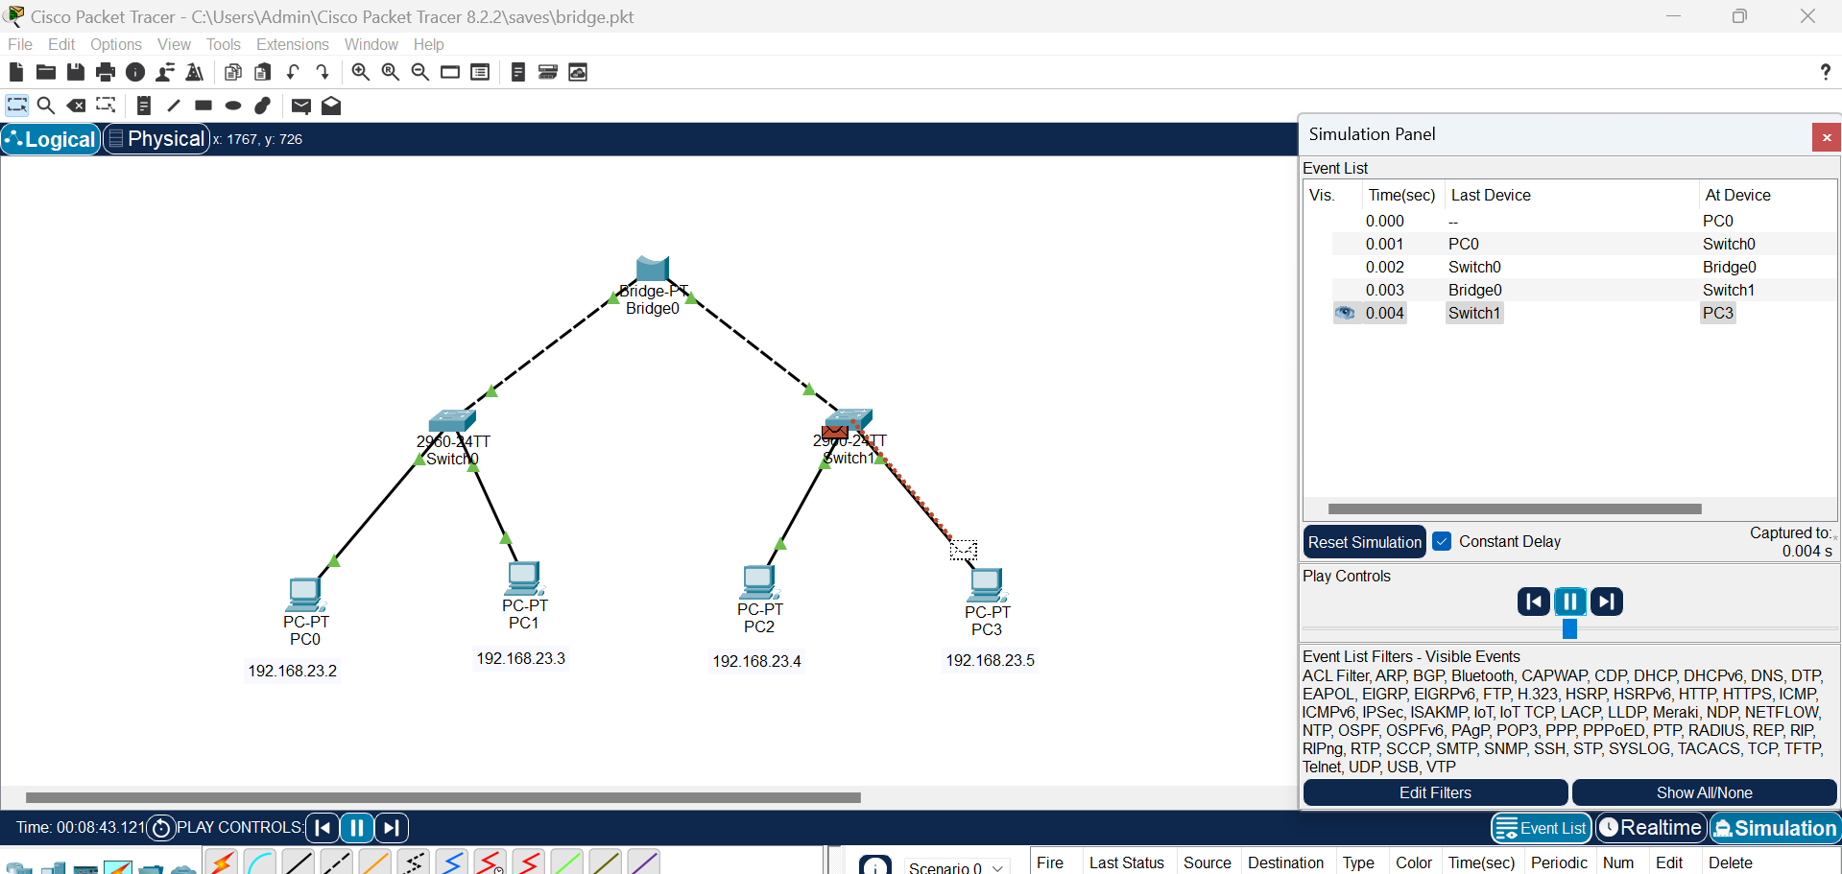

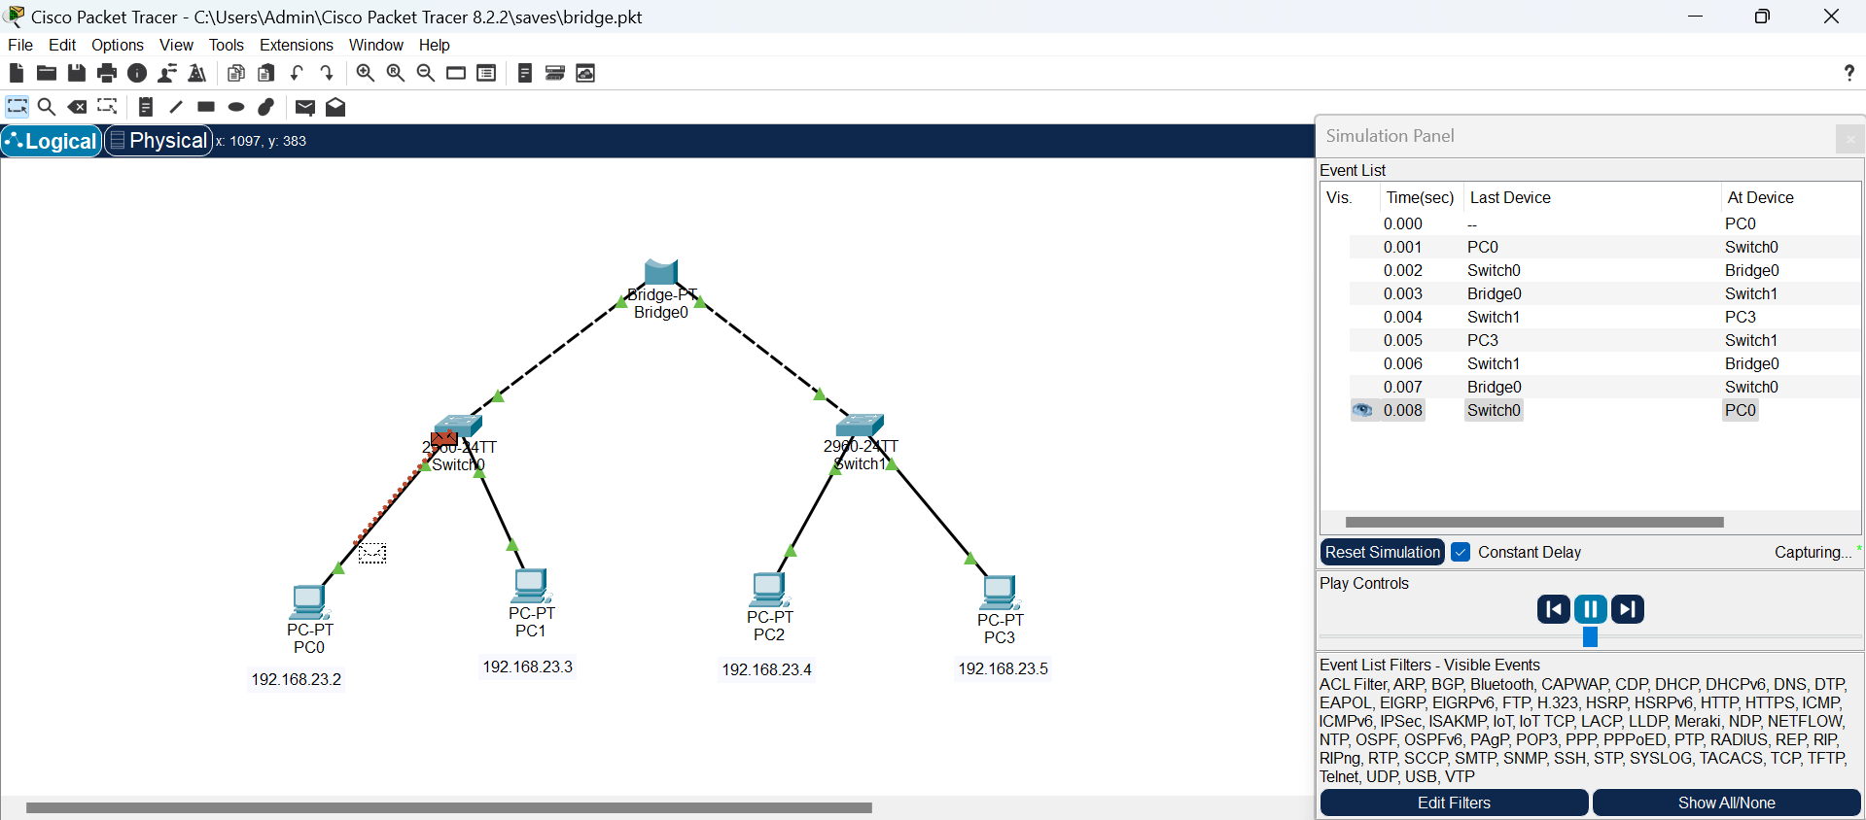

**8. DNS-Domain Name System**

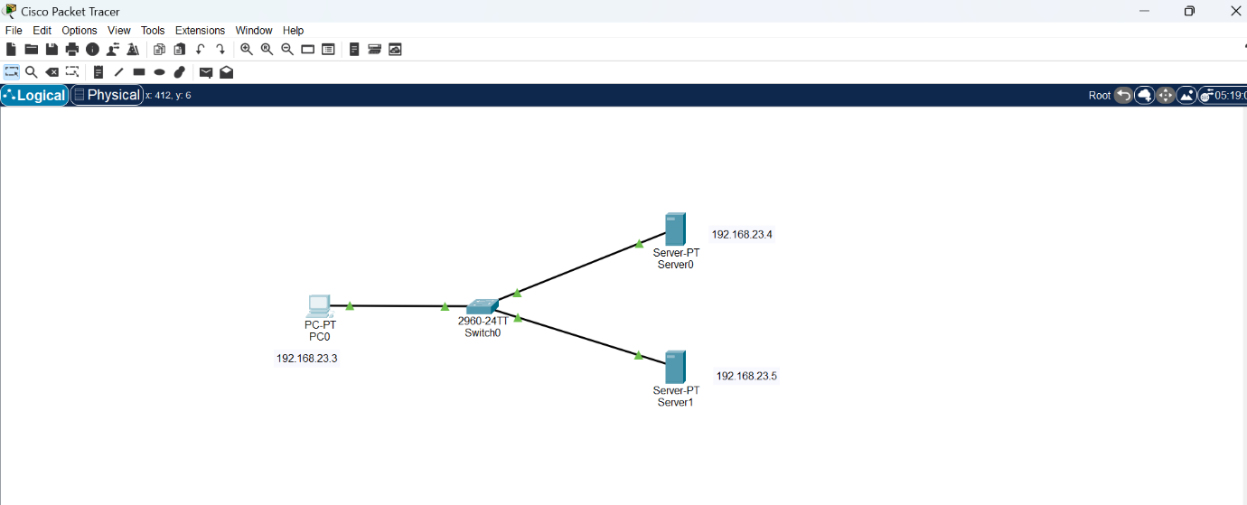

Pinging:

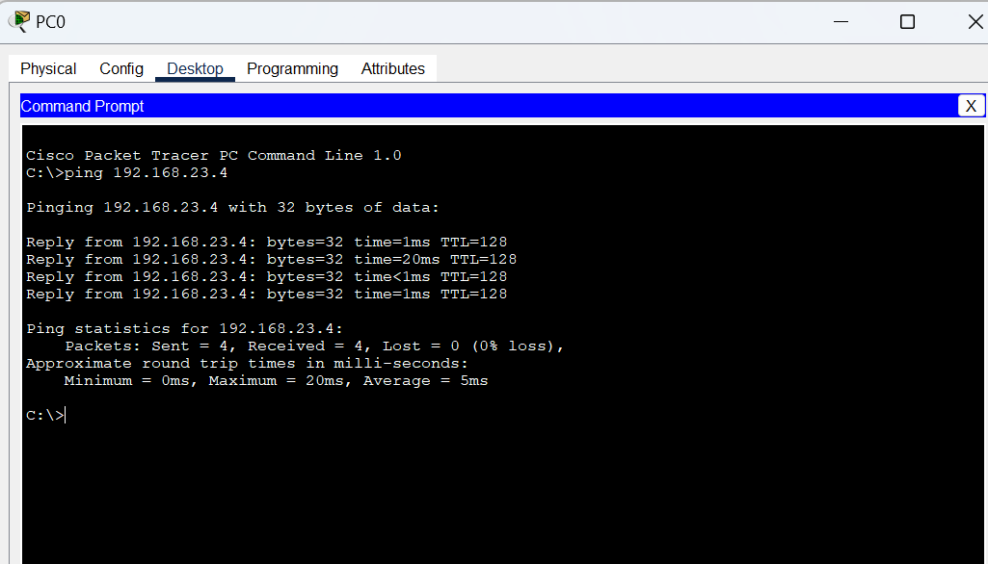

Web browser:

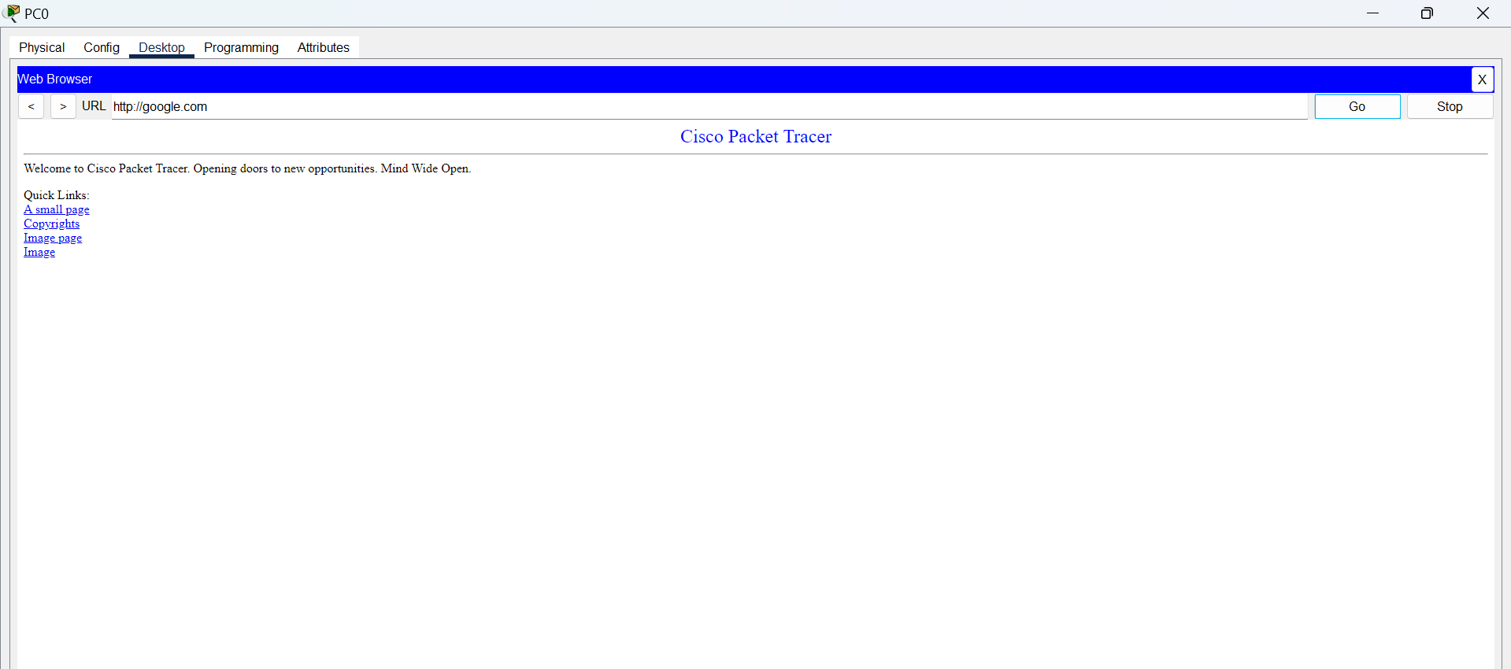

IP configuration:

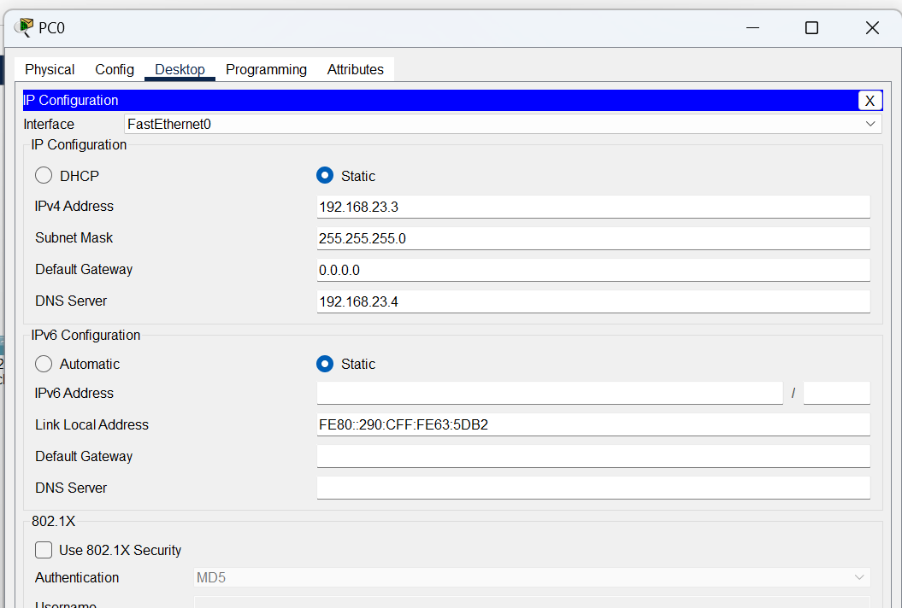

DNS Server:

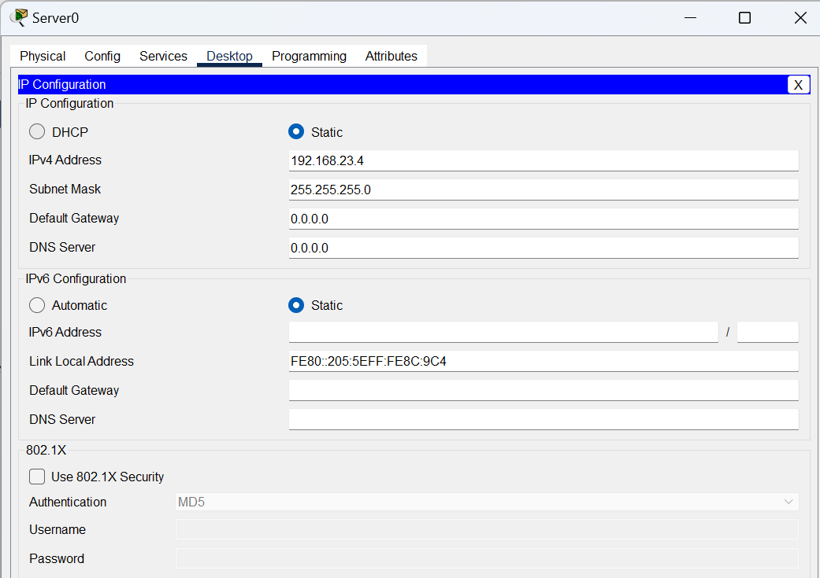

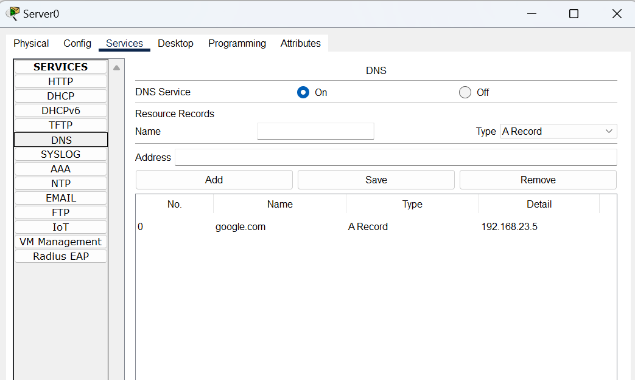

Simulation of message transfer from PC0 to Server0:

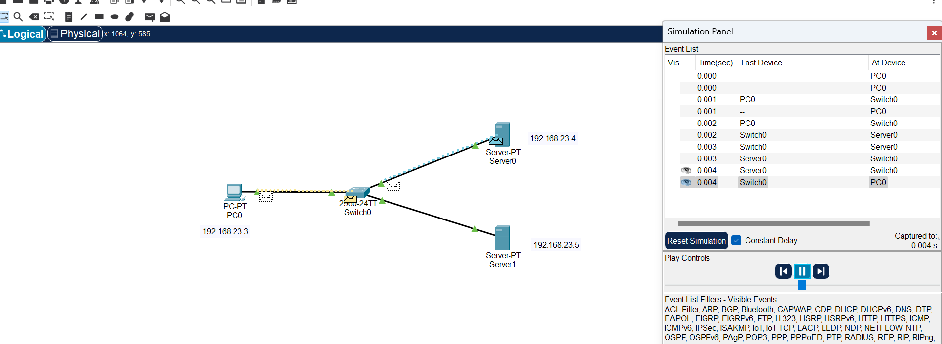

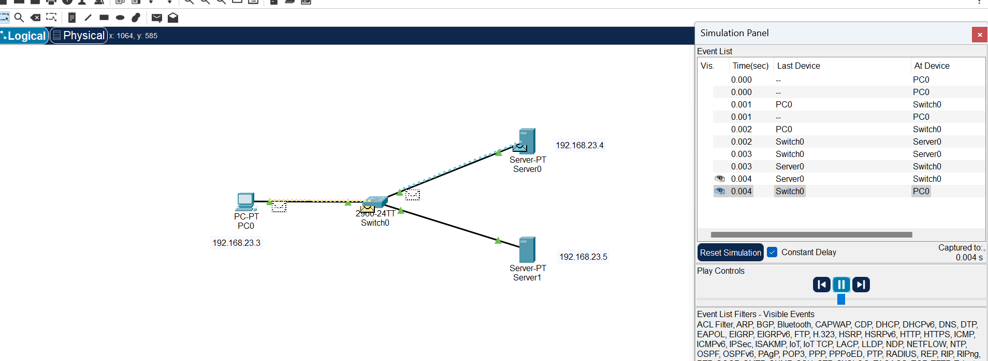

**9. FTP-File Transfer Protocol**

Protocol for transferring files between computers

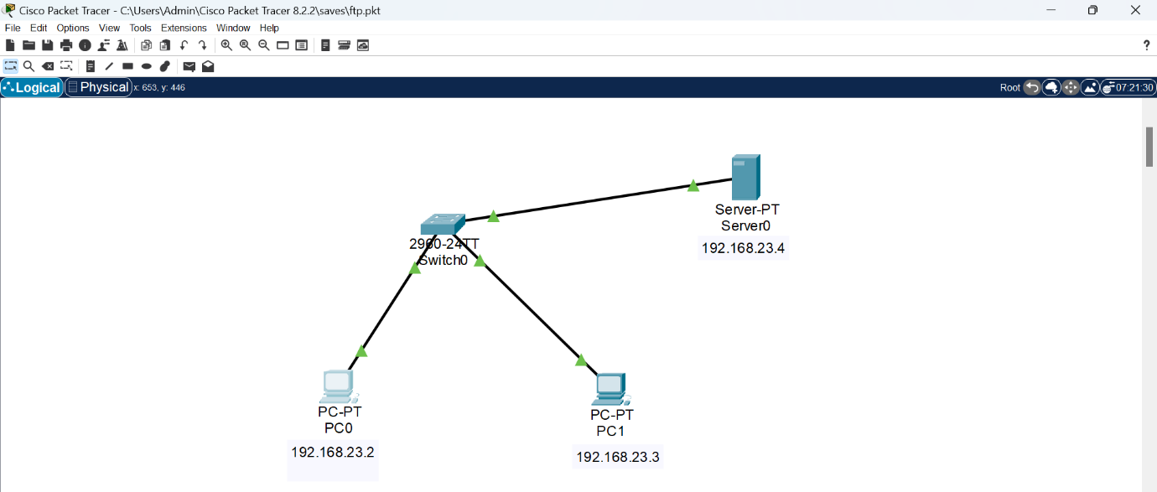

Accessing ftp server:

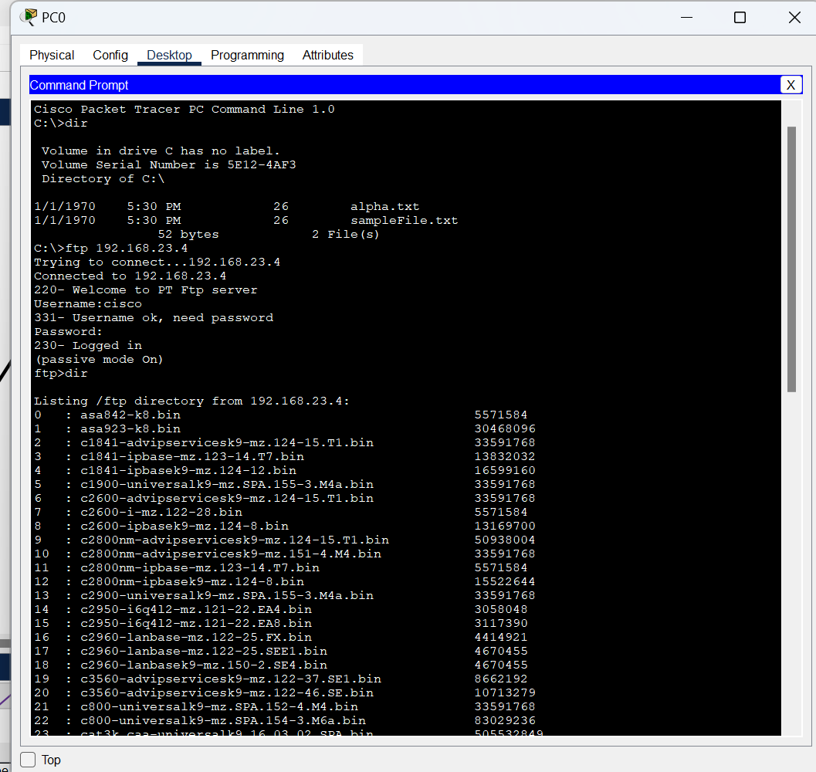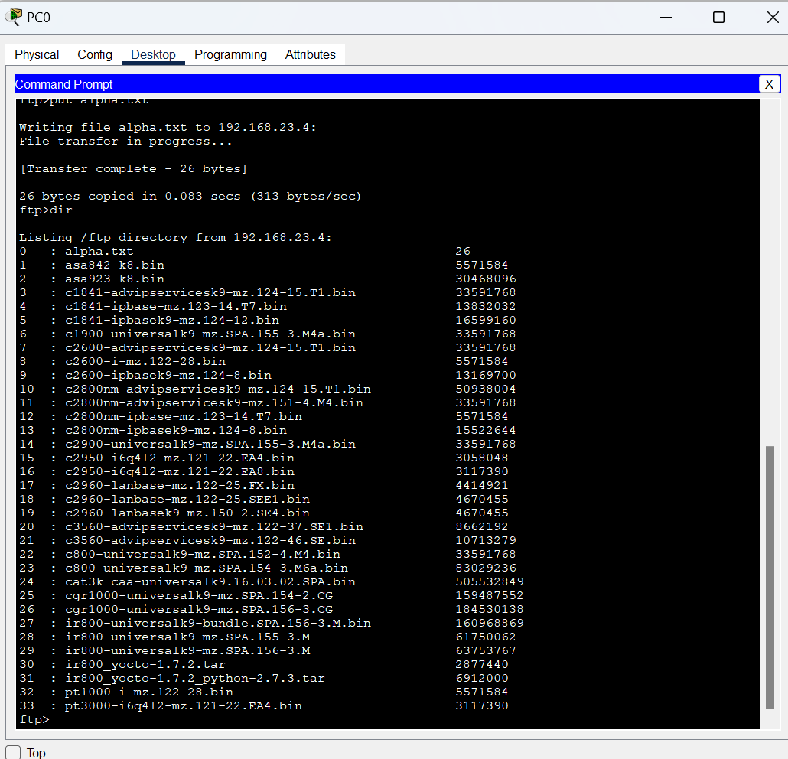

Simulation of message transfer between PC0 and PC1:

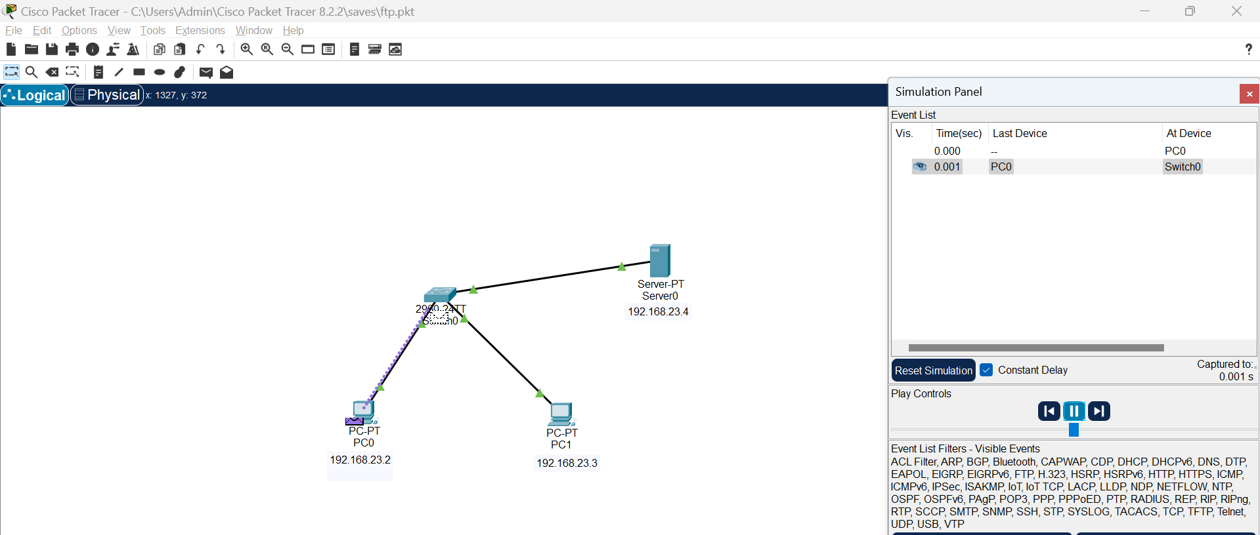

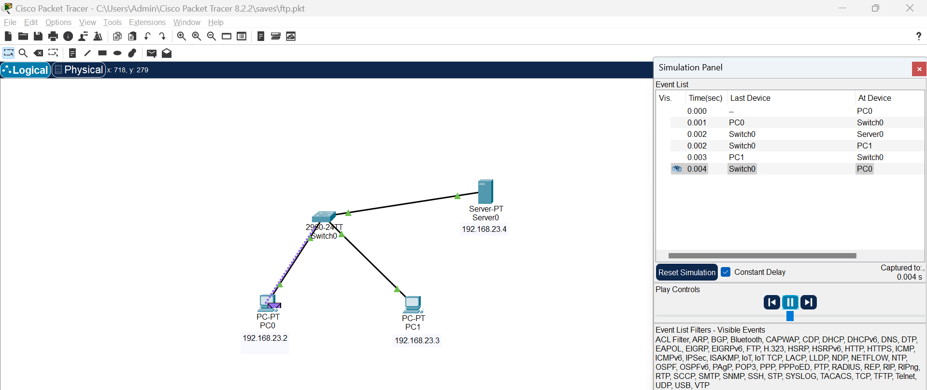

**10. HTTP-Mail**

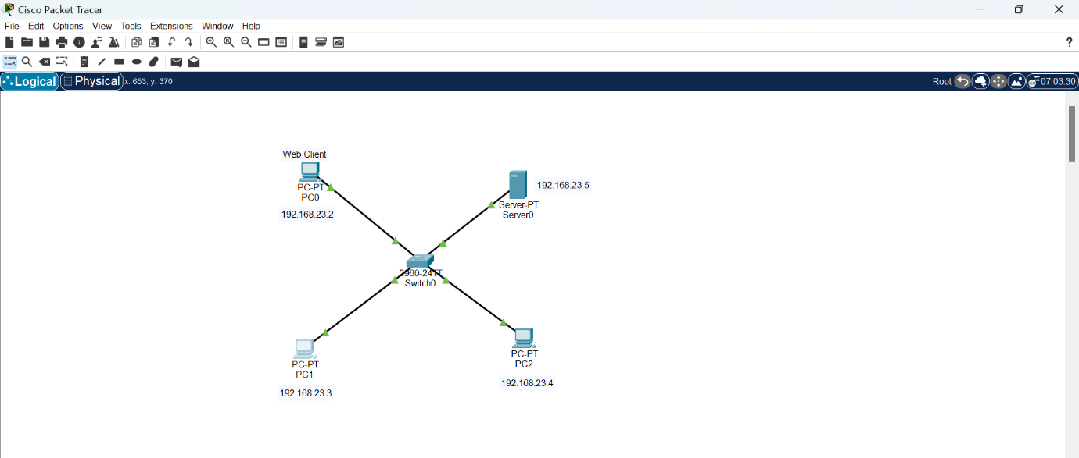

Mail from PC2 to PC1:

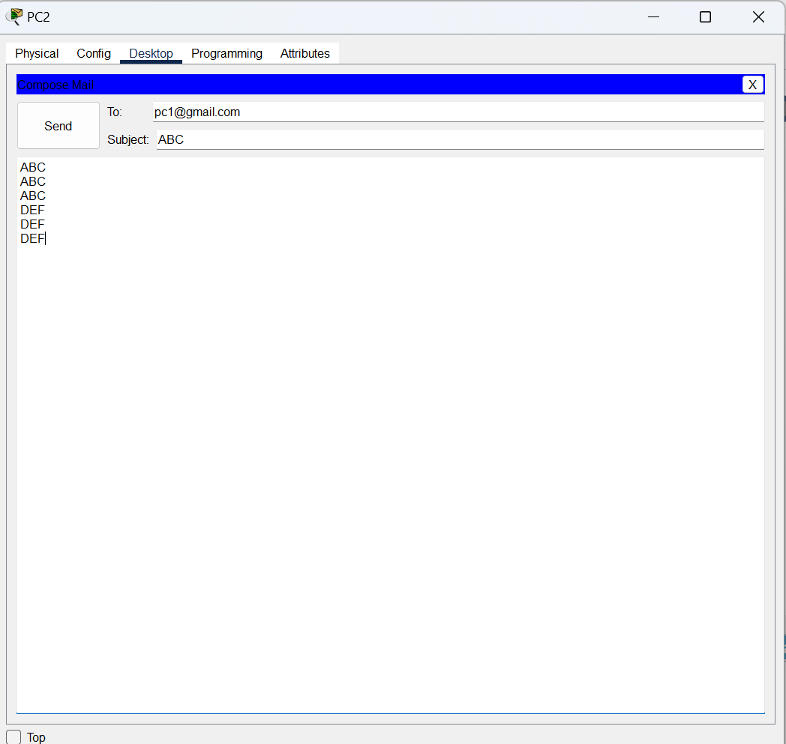

Mail received at PC1:

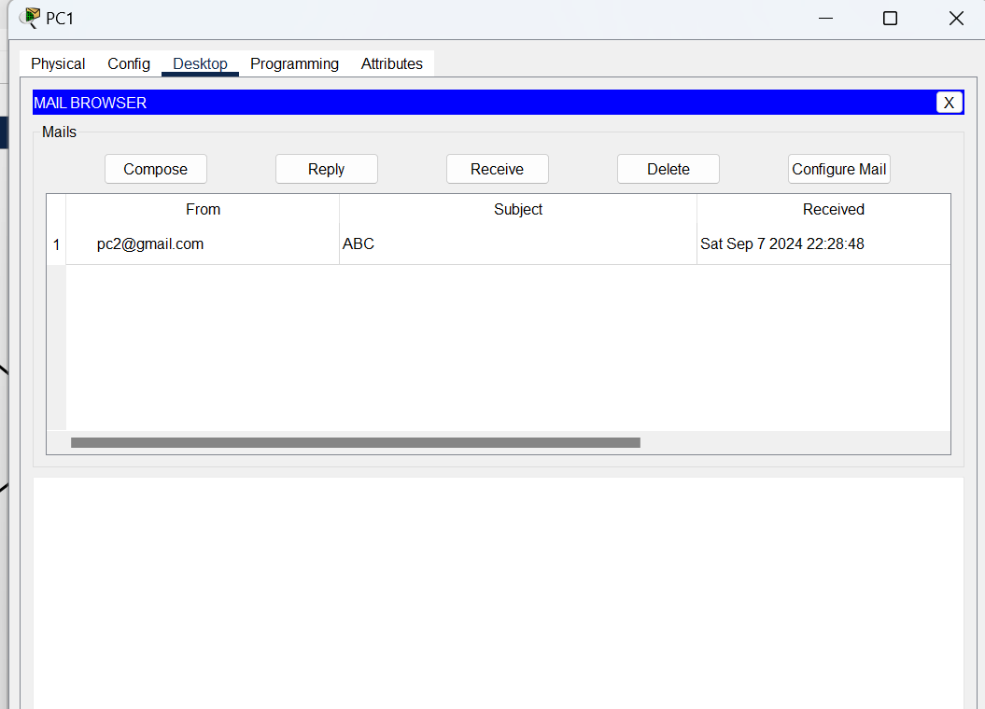

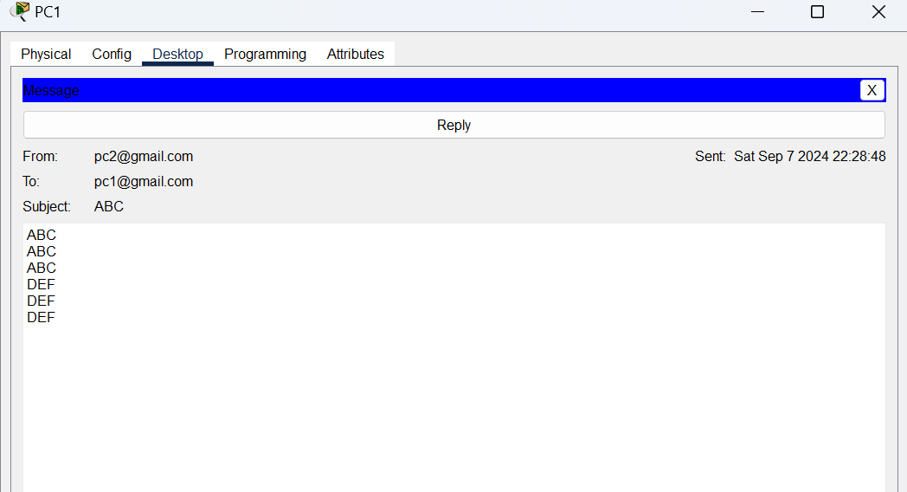

Simulation of message transfer from PC0 to PC2:

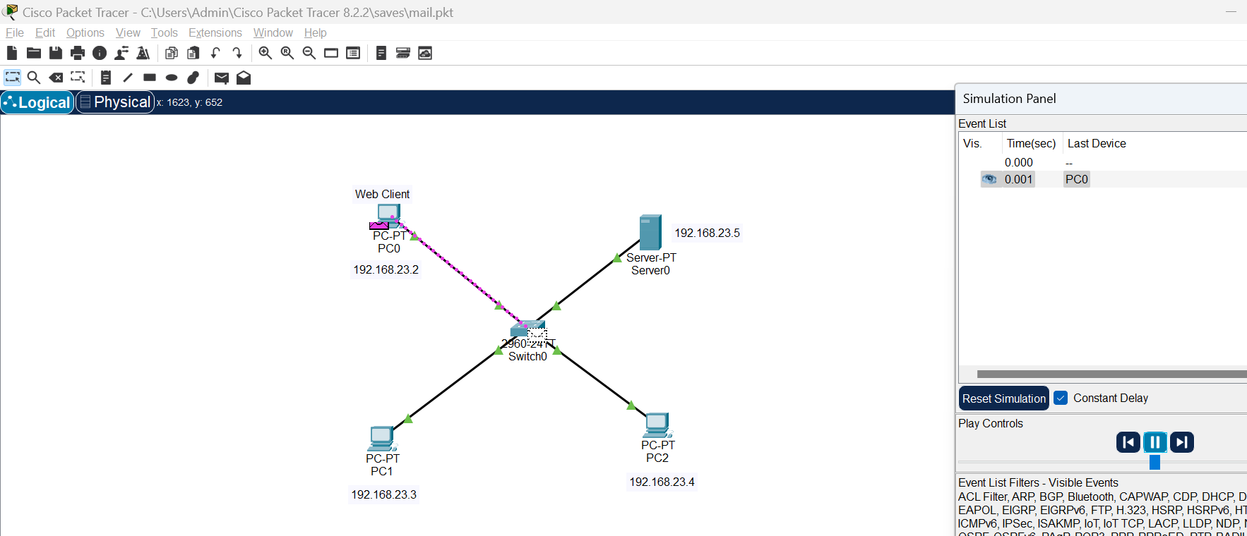

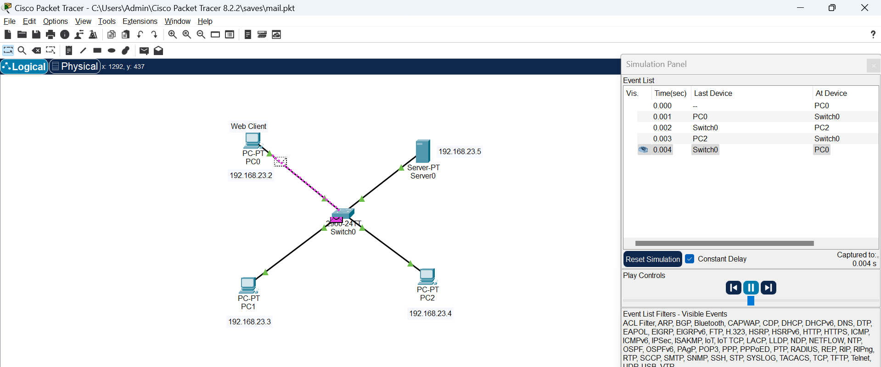

**11. DHCP- Dynamic Host Configuration Protocol**

Dynamic Host Configuration Protocol (DHCP) is a client/server protocol that automatically provides an Internet Protocol (IP) host with its IP address and other related configuration information such as the subnet mask and default gateway.

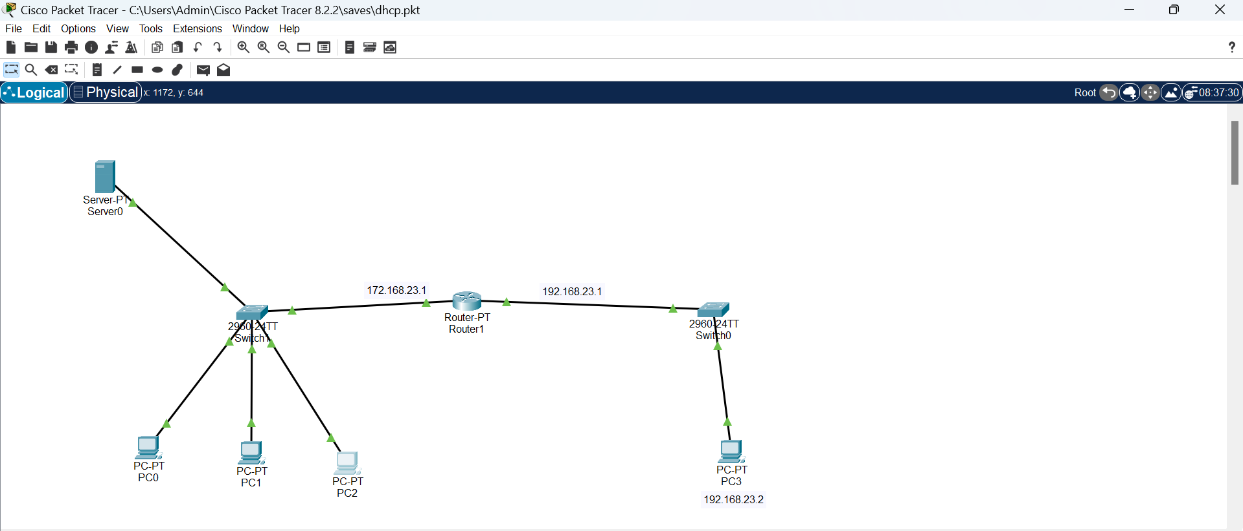

Configuring DHCP Services:

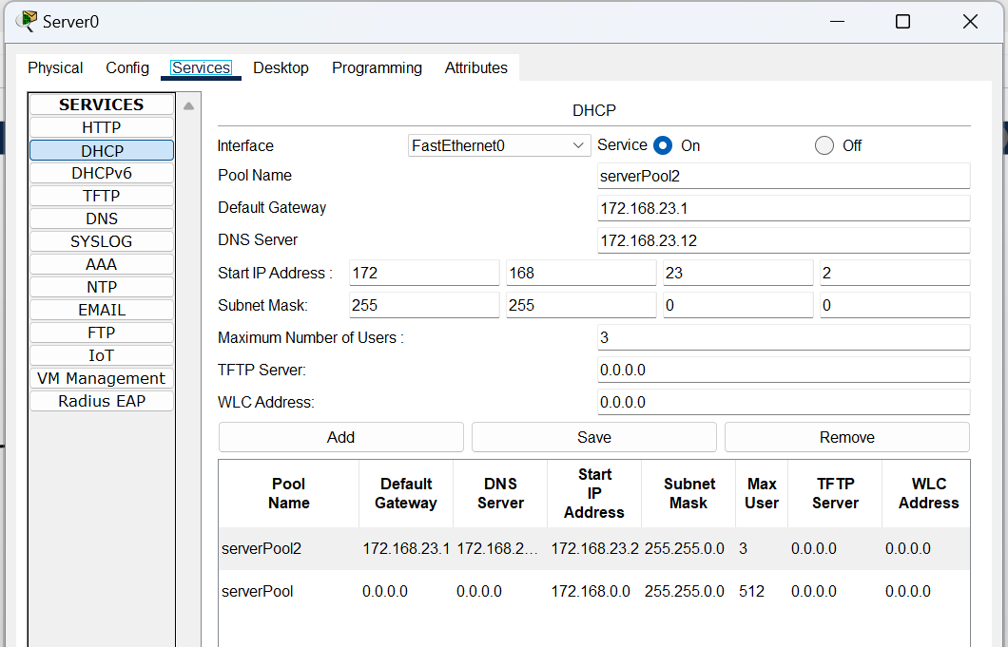

IP Address of PC0:

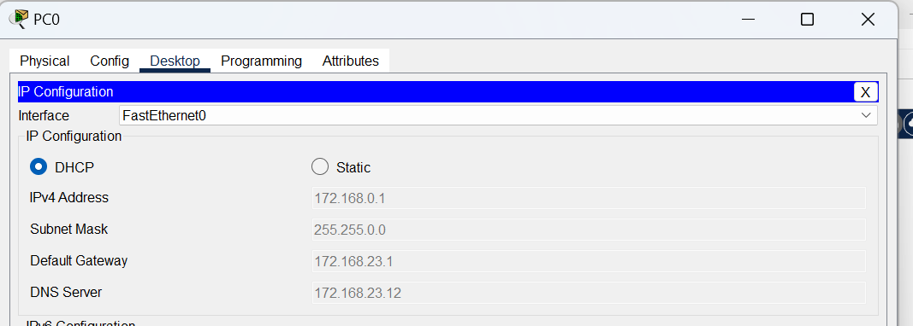

IP Address of PC1:

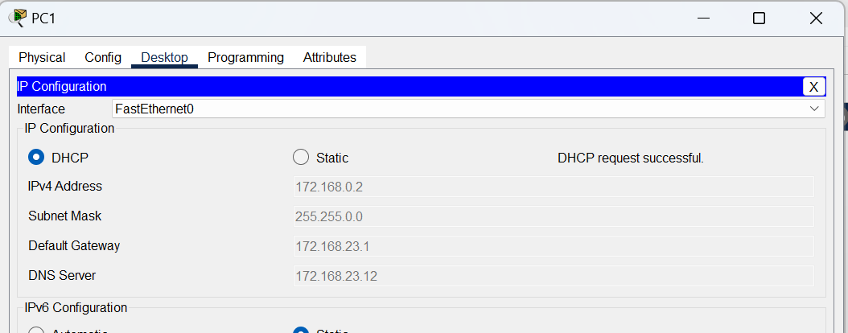

IP Address of PC2:

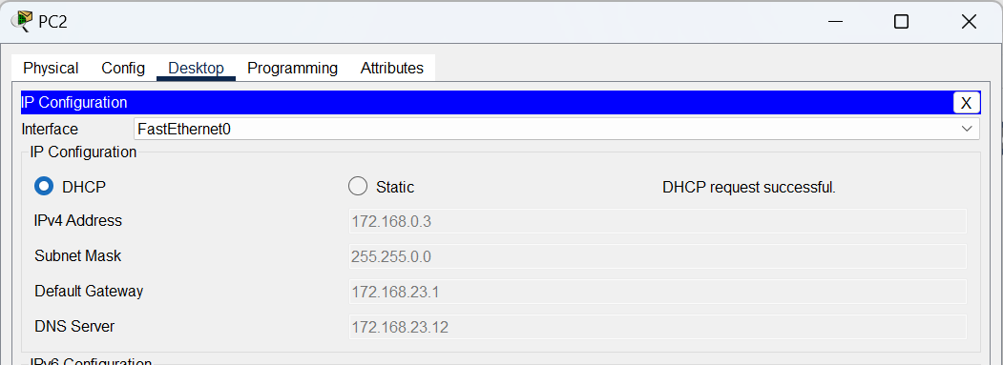

Simulation of message transfer between PC0 and PC3:

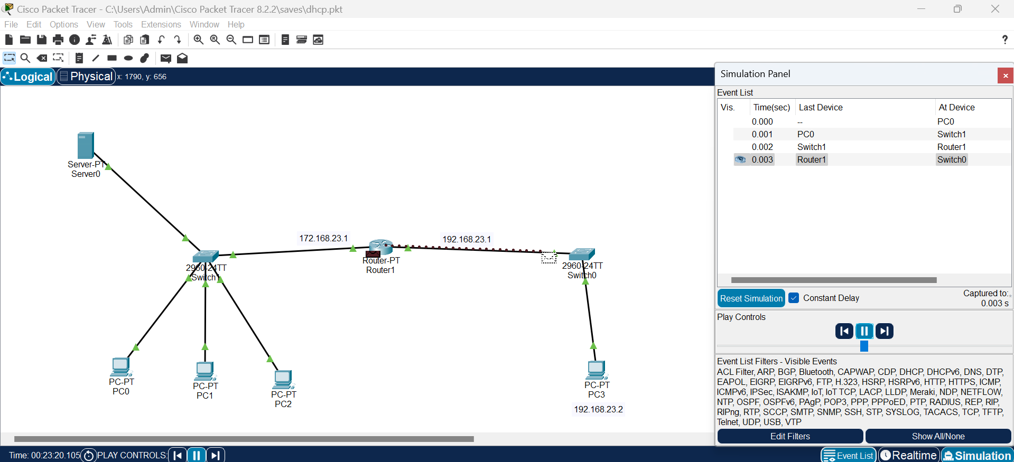

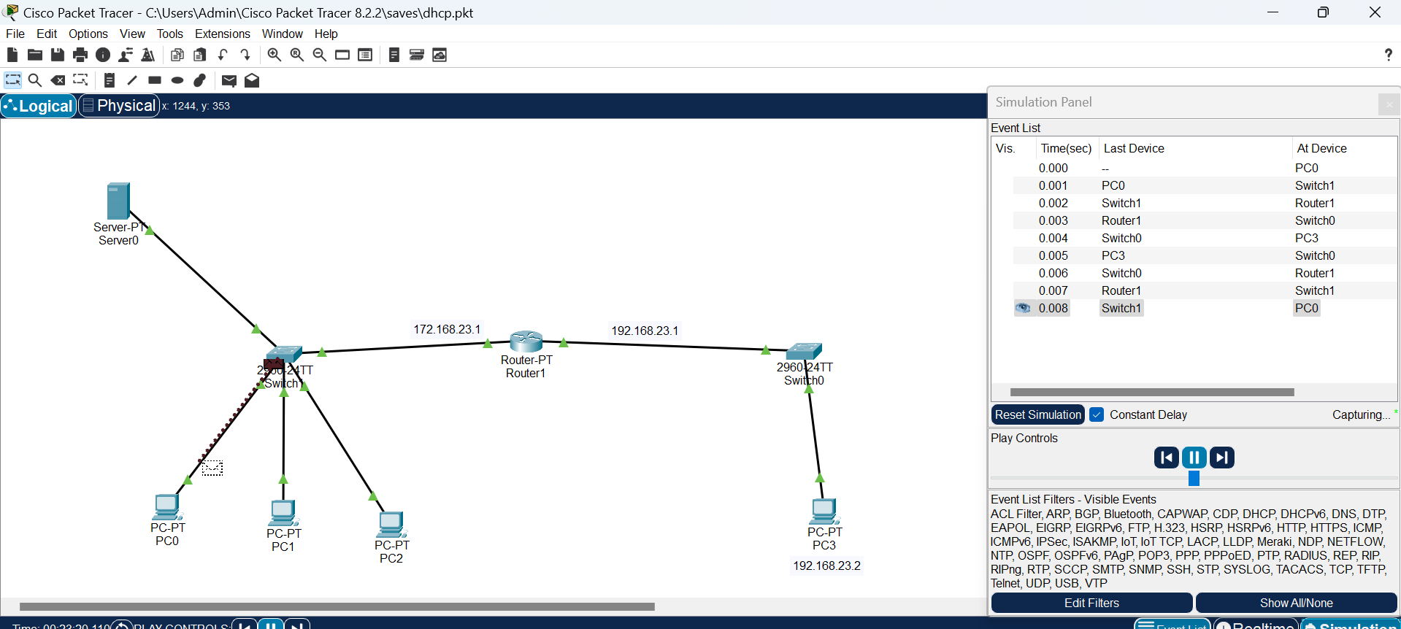

**12. Subnetting**

**(i)Static Subnetting**

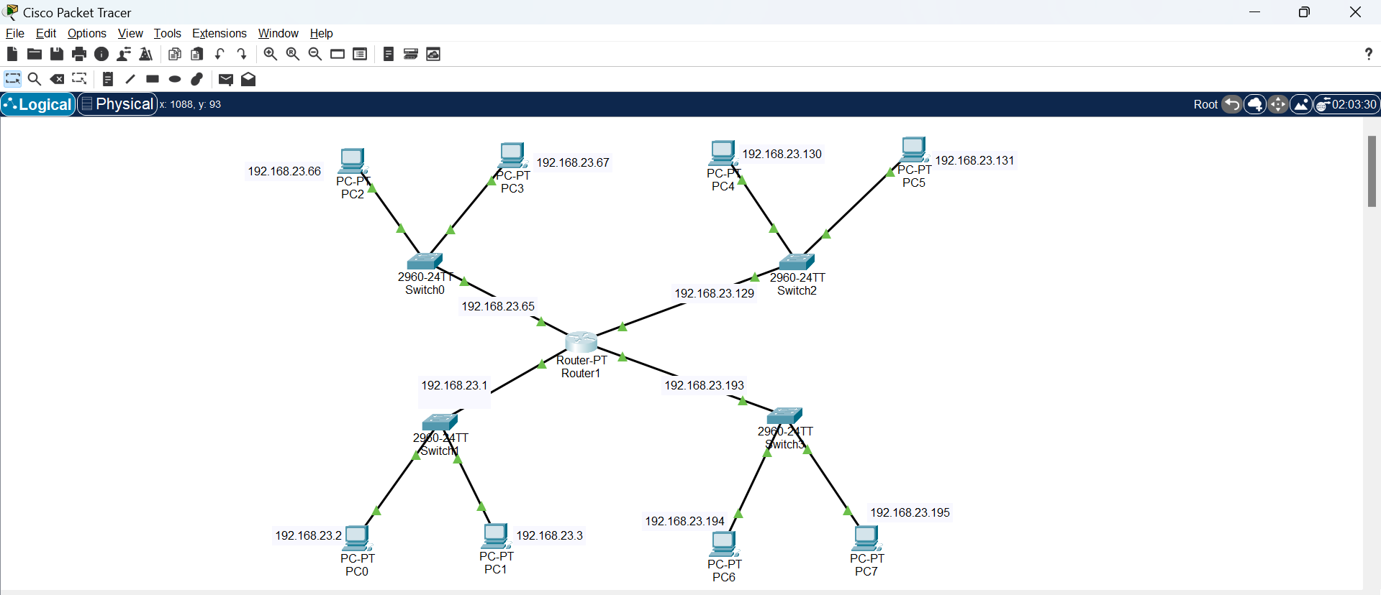

Simulation of a message going to PC0 to PC4 and receiving acknowledgement:

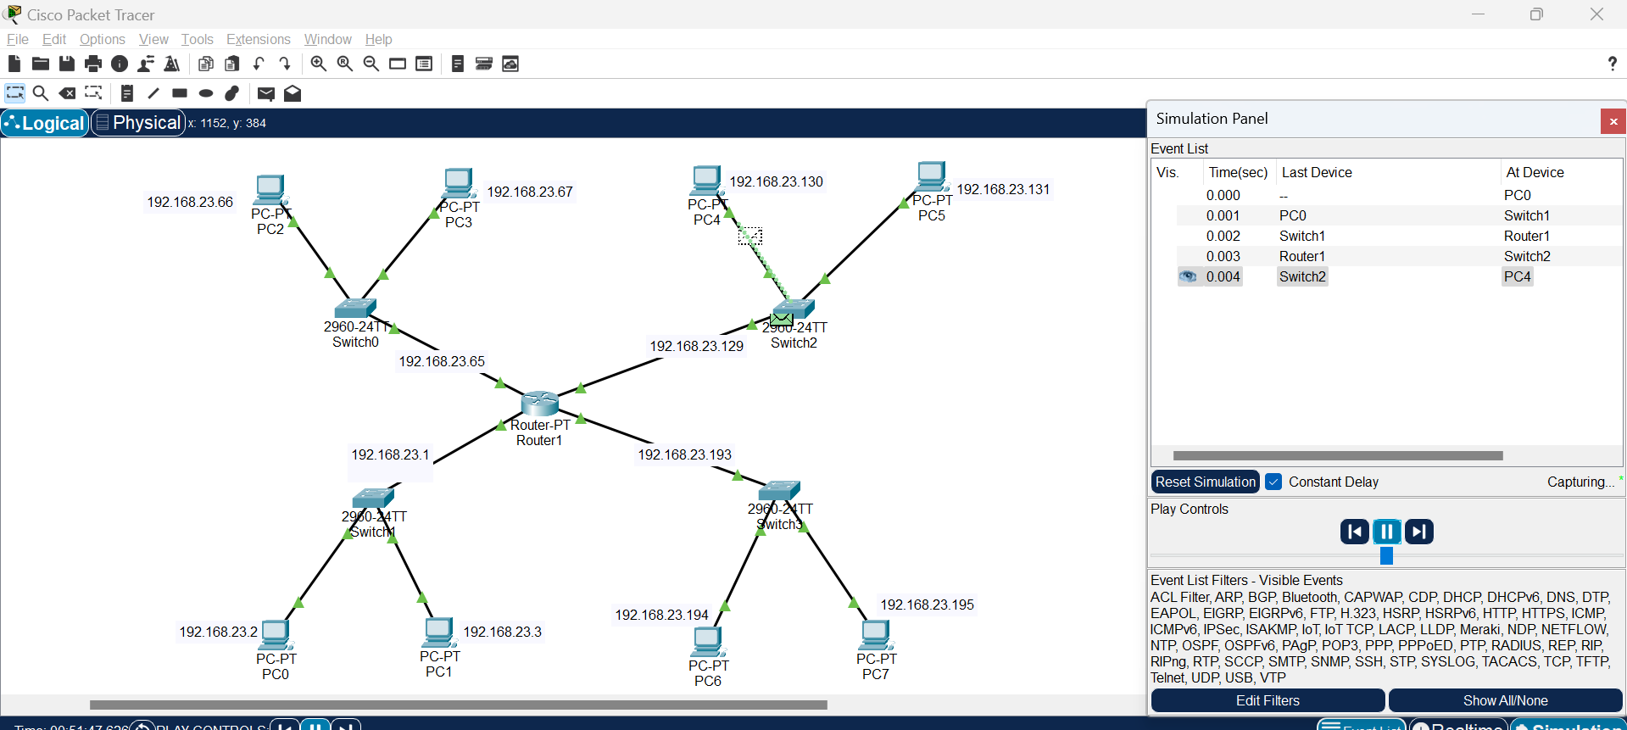

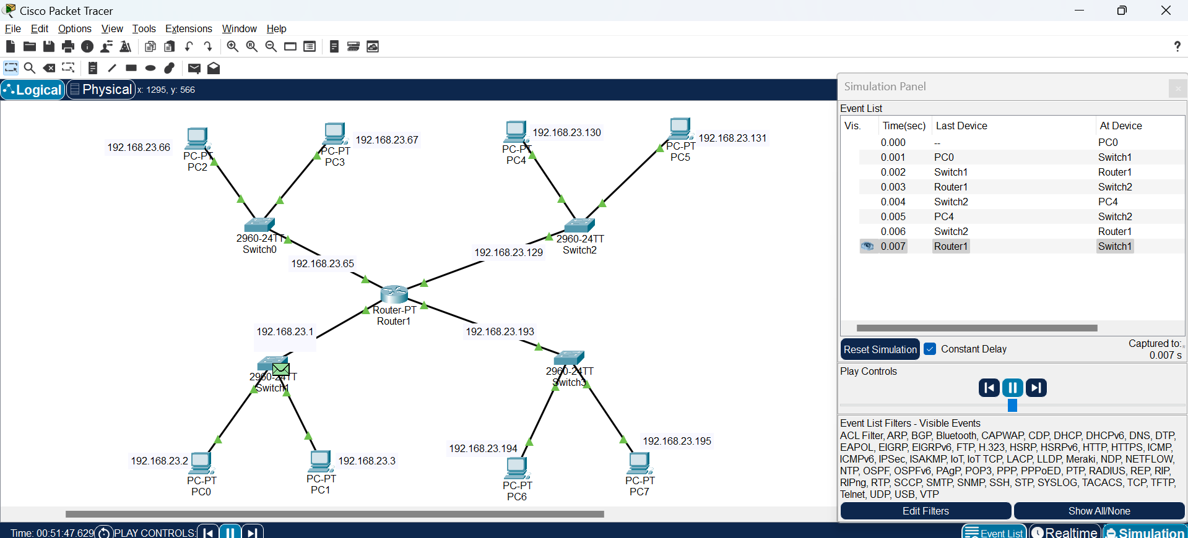

**(ii) VLSM (Variable Length Subnet Mask) Subnetting**

Given network: 192.168.23.0/20

**PC0**- 200 hosts- 8 bits- Maximum number of users=256-Subnet Mask- 255.255.255.0

IP Address-192.168.23.2

**PC1**- 100 hosts- 7 bits- Maximum number of users=128-Subnet Mask- 255.255.255.128

**PC2**- 50 hosts- 6 bits- Maximum number of users=64-Subnet Mask- 255.255.255.192

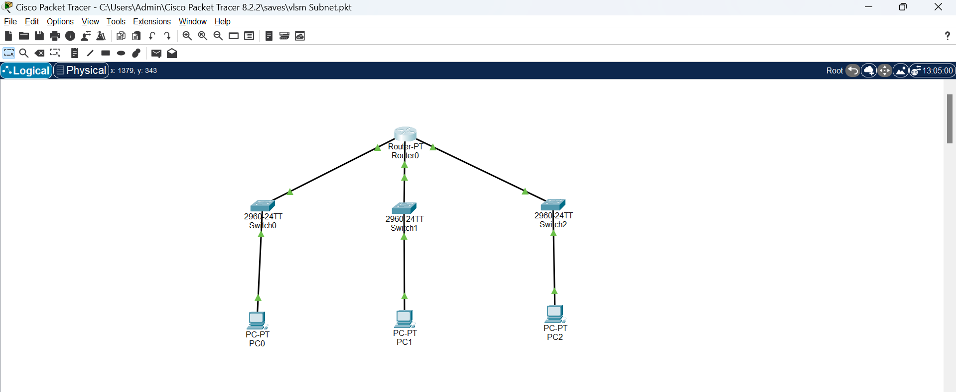

Simulating a message sent from PC0 to PC2:

